*Florida International University*

*School of Computing and Information Sciences*

CIS 4911 - Senior Capstone Project

Software Engineering Focus

HyperDesk 1.0:)

User Manual

**Team Members:**

Rachelle Tobkes

Daniel Alvarez

**Product Owner(s)**:

Pia Celestino

**Mentor(s)**:

Pia Celestino

**Instructor:**

Masoud Sadjadi

Table Of Contents

Register…………………………………………………..………….……..3

Search……………………………………………………………..……….6

Sign-In…………………………………...……………………….....…….10

List a Space…………………………………..……………….………….11

Set Up Bank Account………………………..…………….………….…14

Save Card Details………………………………………….……...….…15

Accept/Decline Offers………………………………..…………....….…18

Write a Review/Rate…………………………………………….….……20

Forgot Password……………………………………………….….…..…22

Make an Offer……………………………………………………..…...…24

Message User……………………………………..…...……….……..…27

Edit Profile……………………………………………………….….……29

Rent Office Space……………………………………………….…..…..33

Logout…………………………………………………..………….…..…36

# Register

____________________________________________________________________________

To Register for the HyperDesk system, simply navigate to the Register page by first clicking the **Menu** Tab shown on the left of the homepage and then click **Register**.

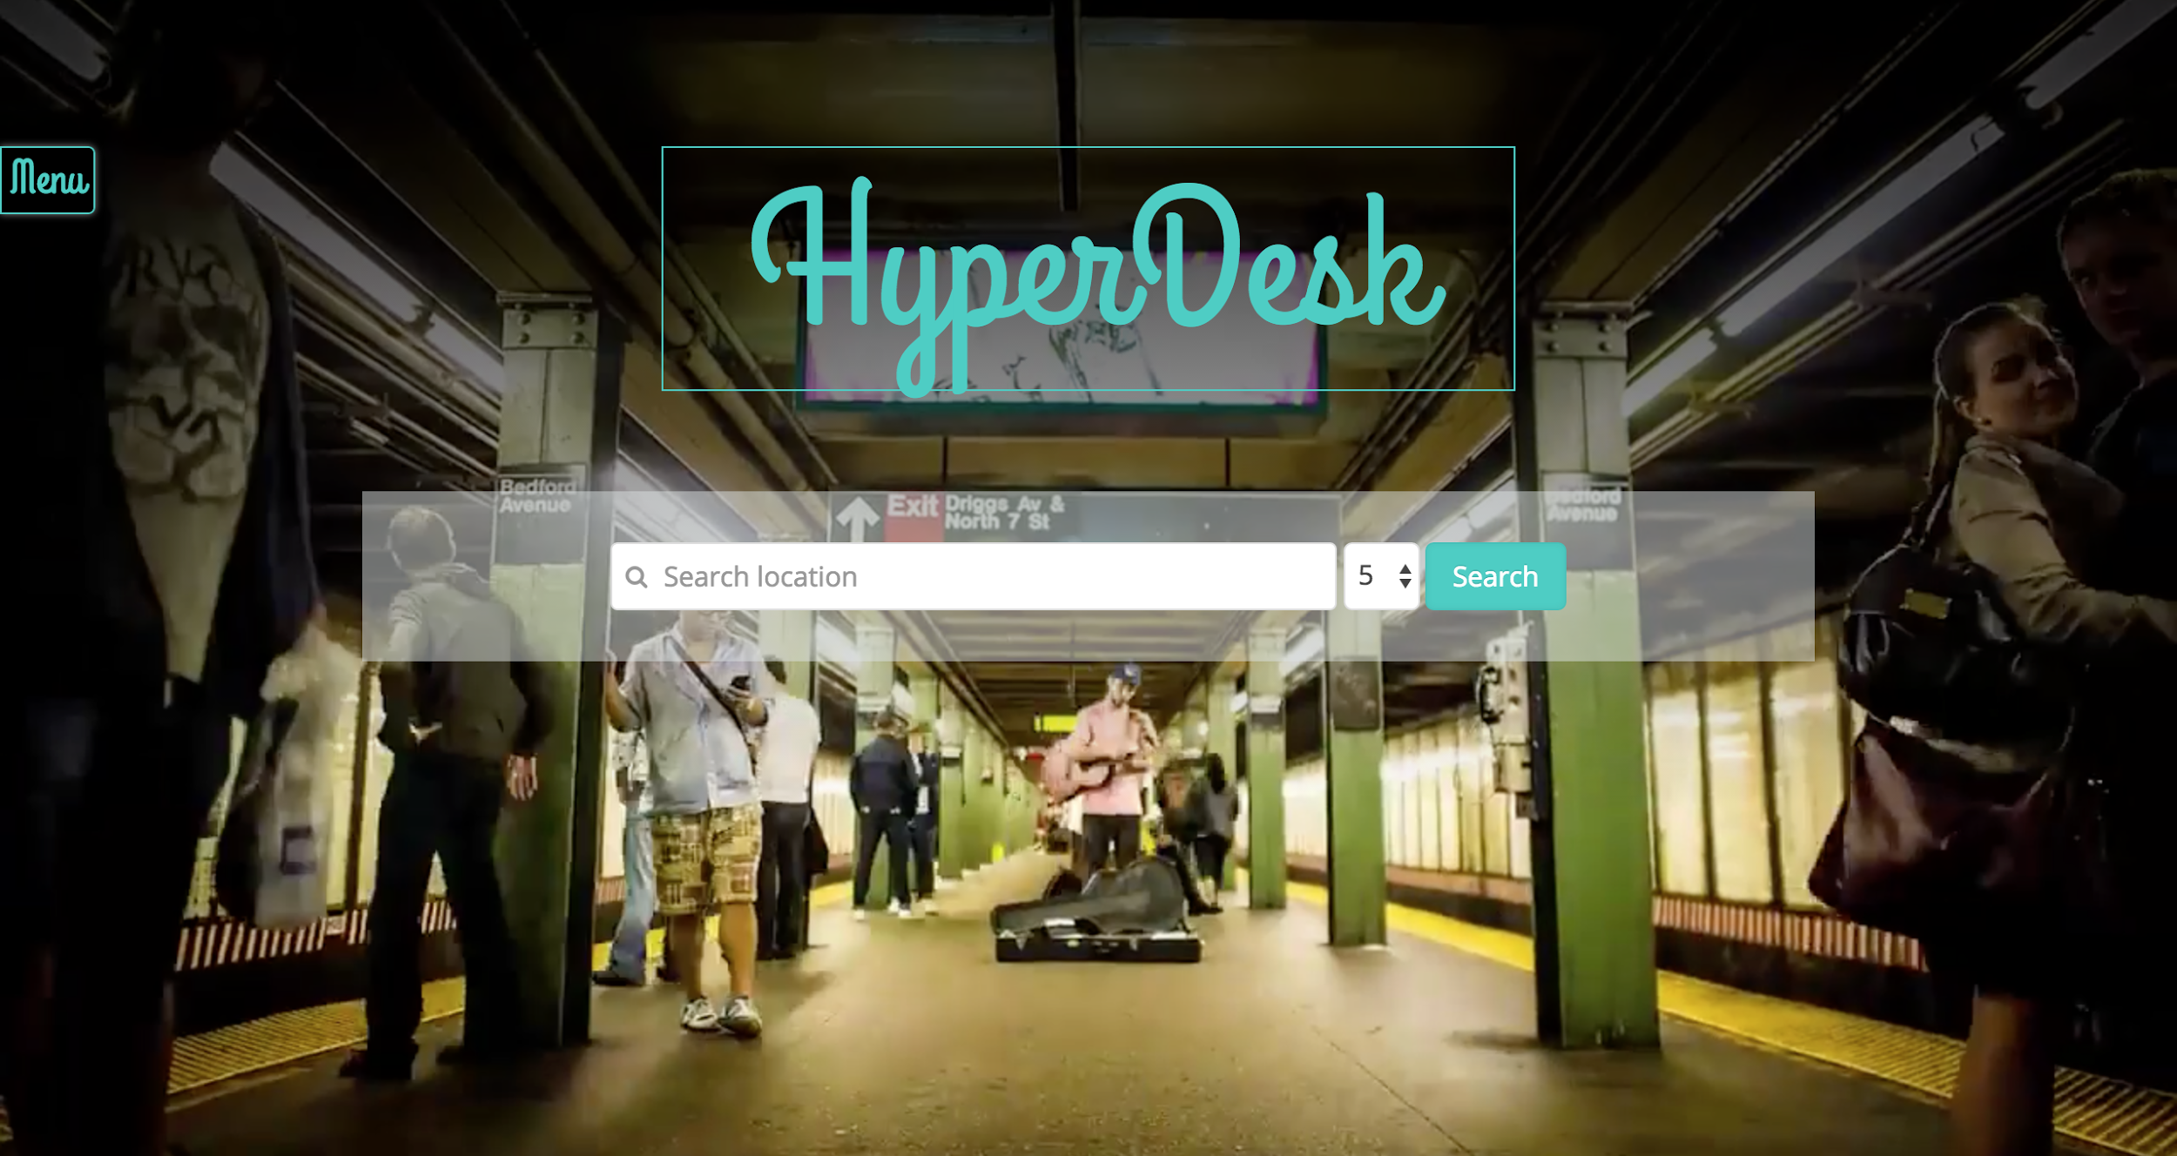

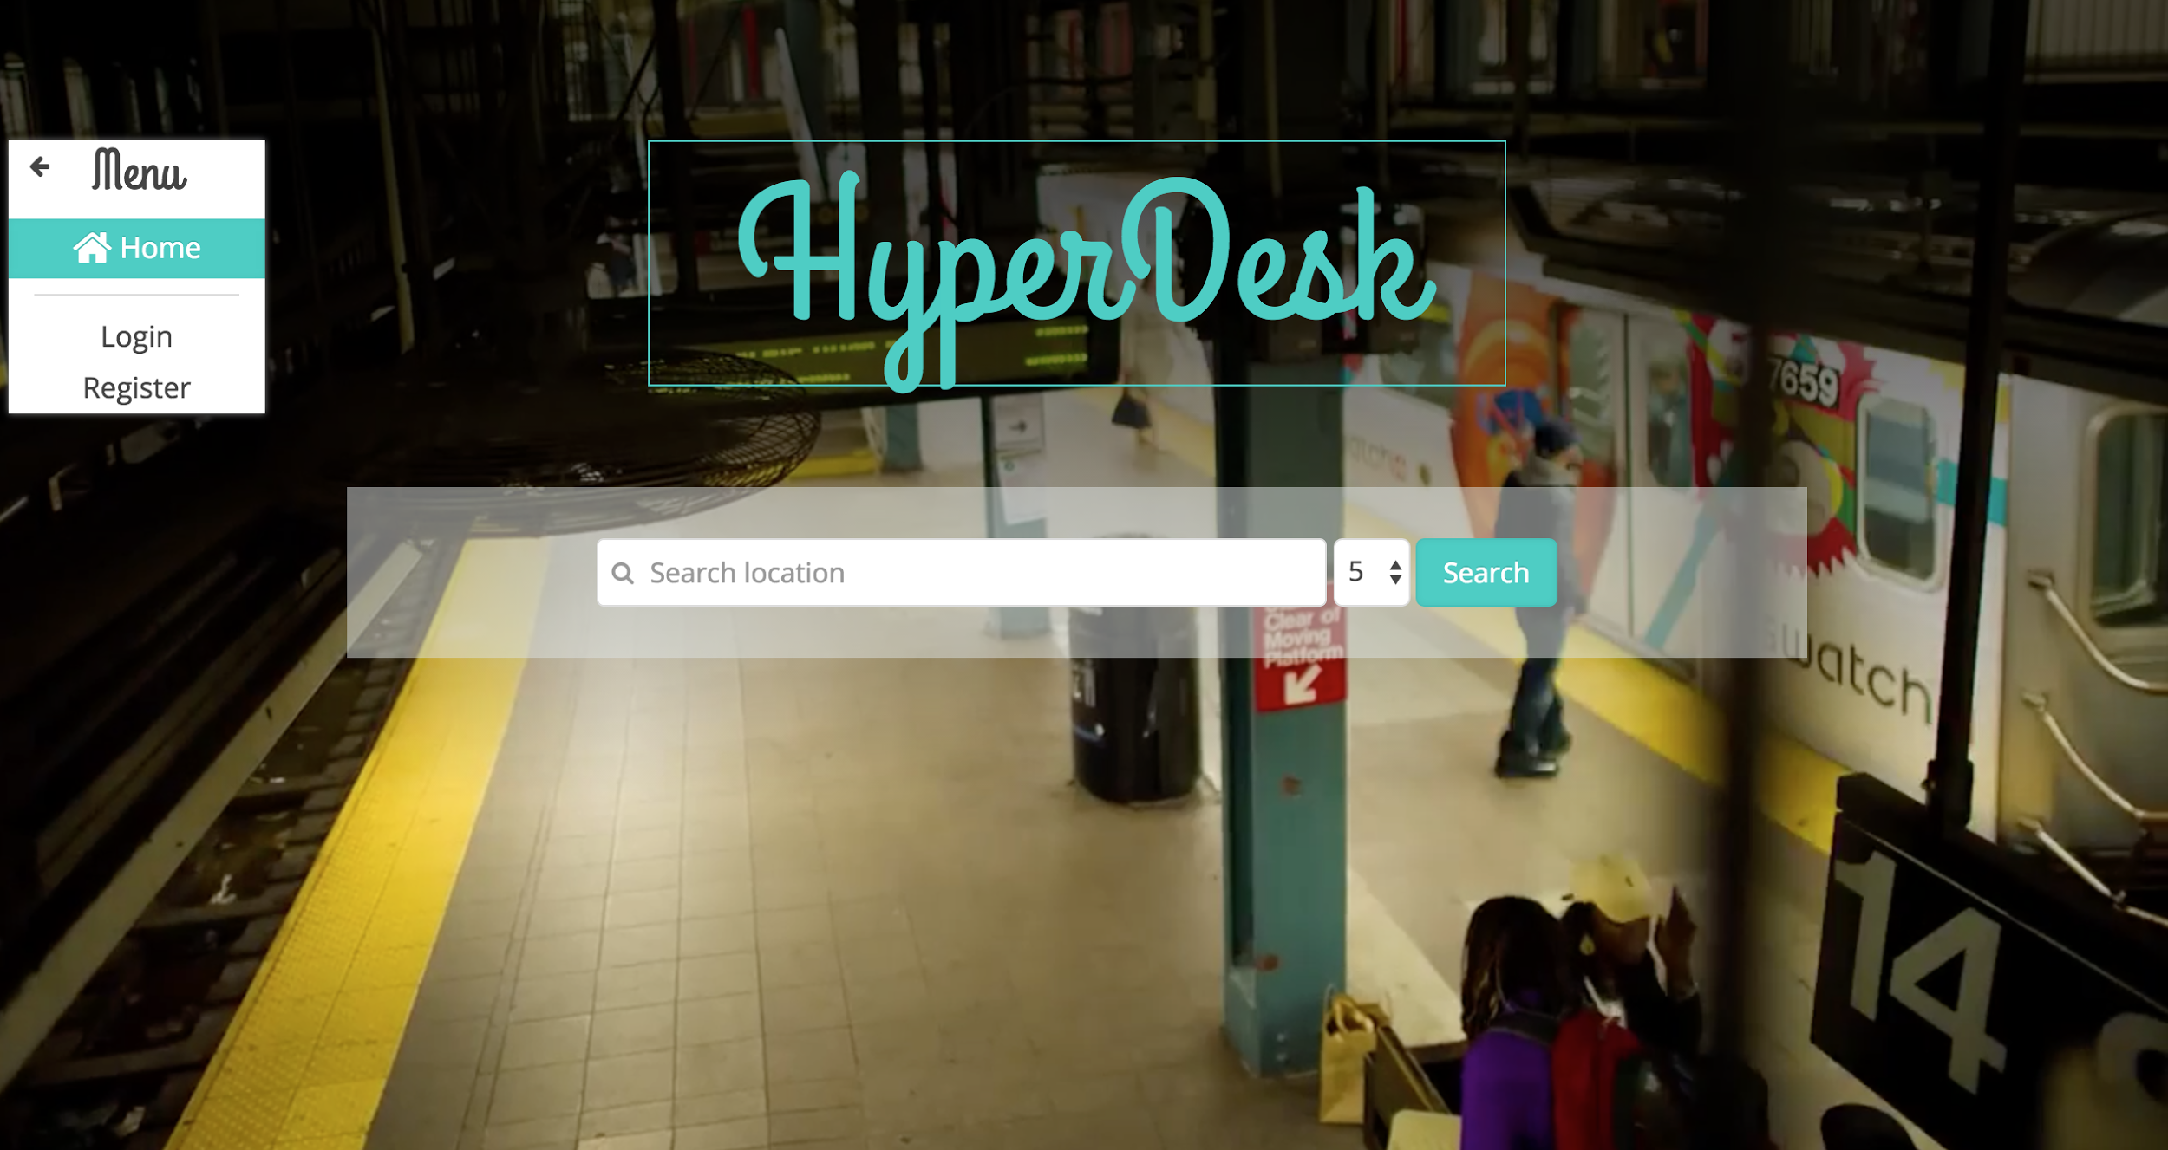

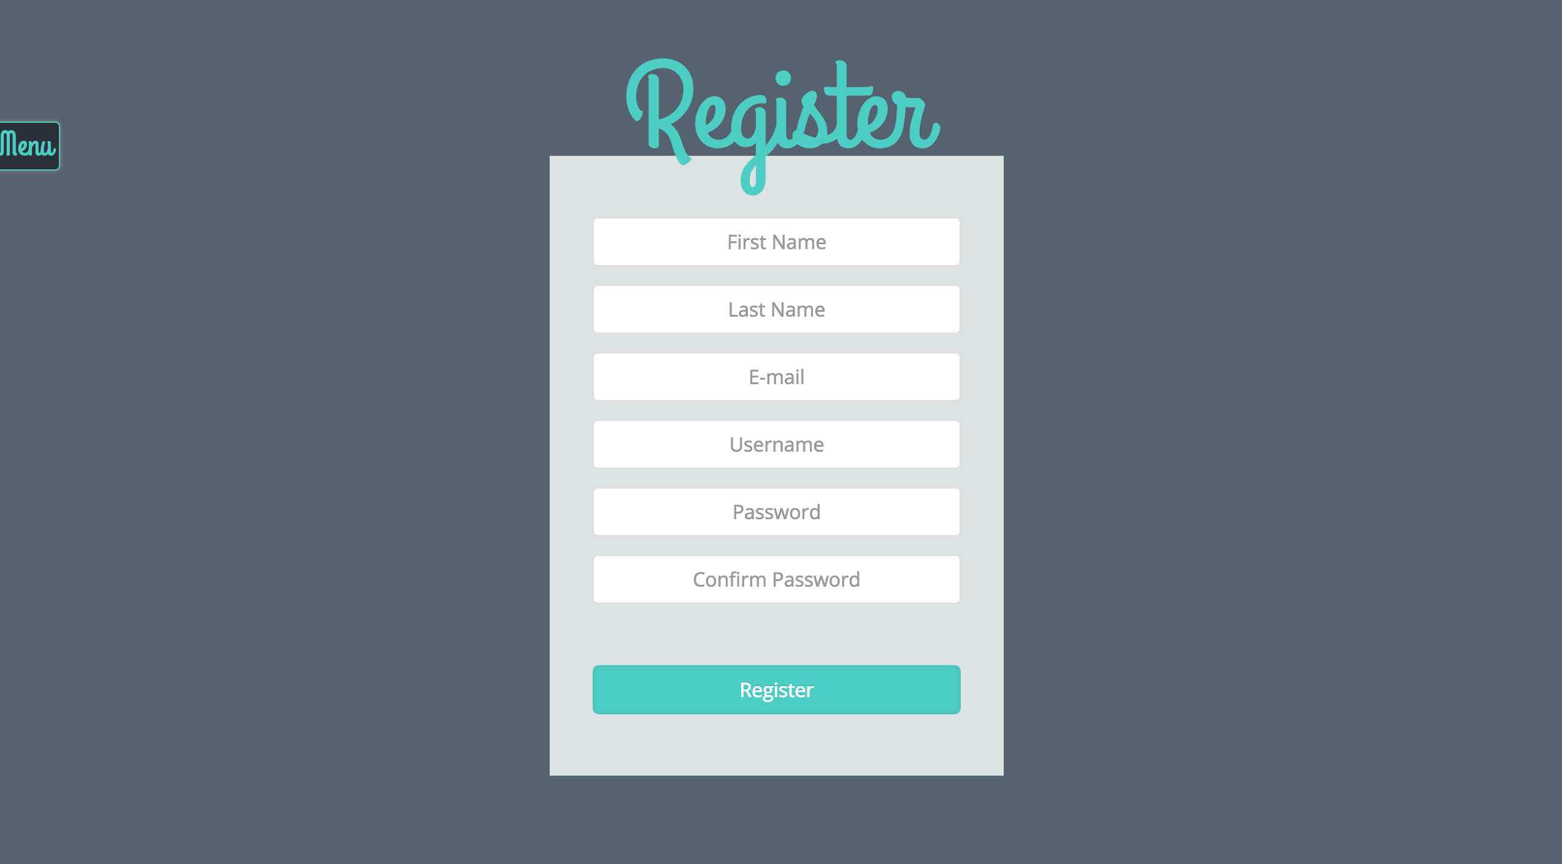

Fill out all of the required fields, and click **Register** once done. You will be taken to the following page:

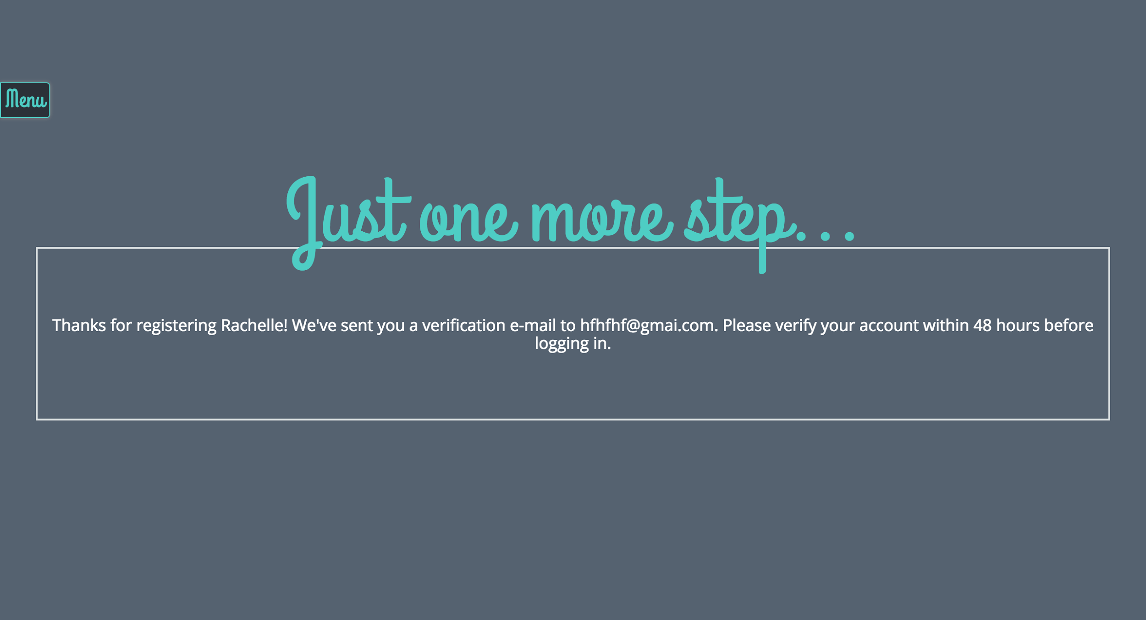

Check your email and verify the link. Then you will be able to sign into the system.

# 

# 

# 

# Search

____________________________________________________________________________

Begin your office space search by typing a location into the search box. Make sure to select from the drop down list to ensure that the address is typed properly. You can also choose the distance from your location as being 5, 10, 25, or 50 miles.

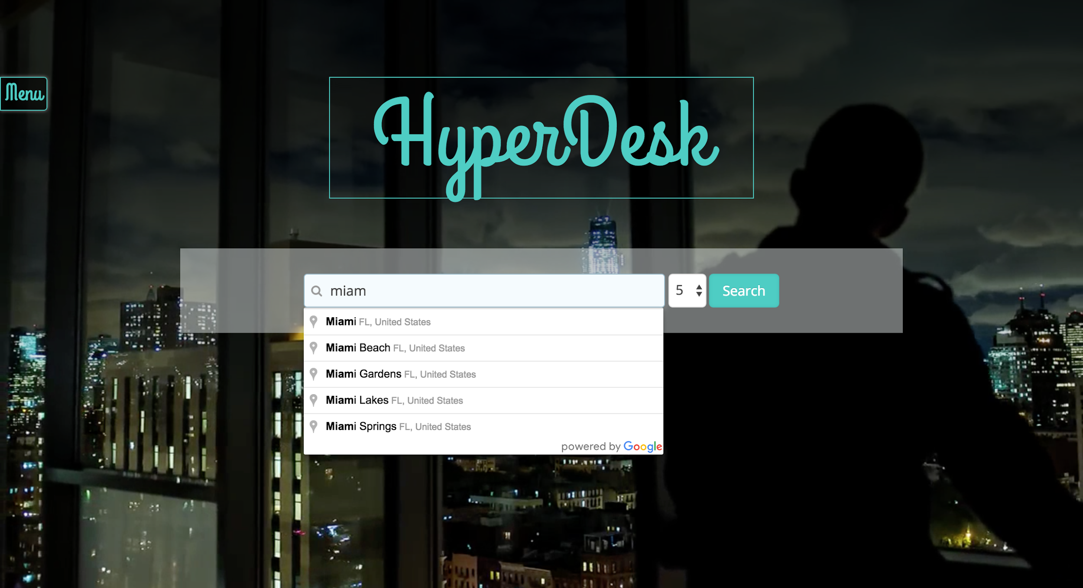

Your search results will be shown in a list as shown below:

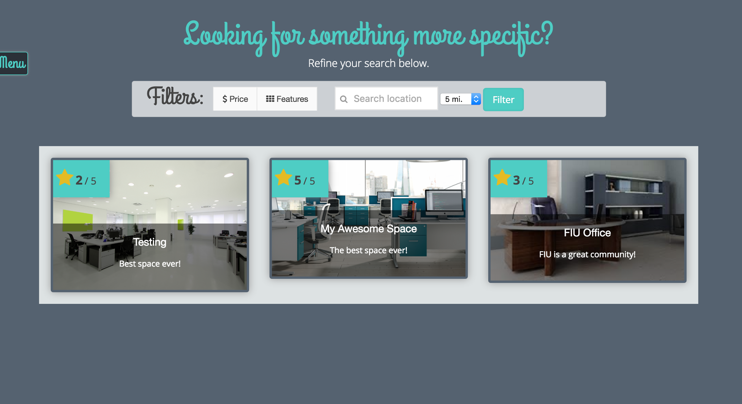

You can filter your search results by choosing the price range or the features that you want your office space to have:

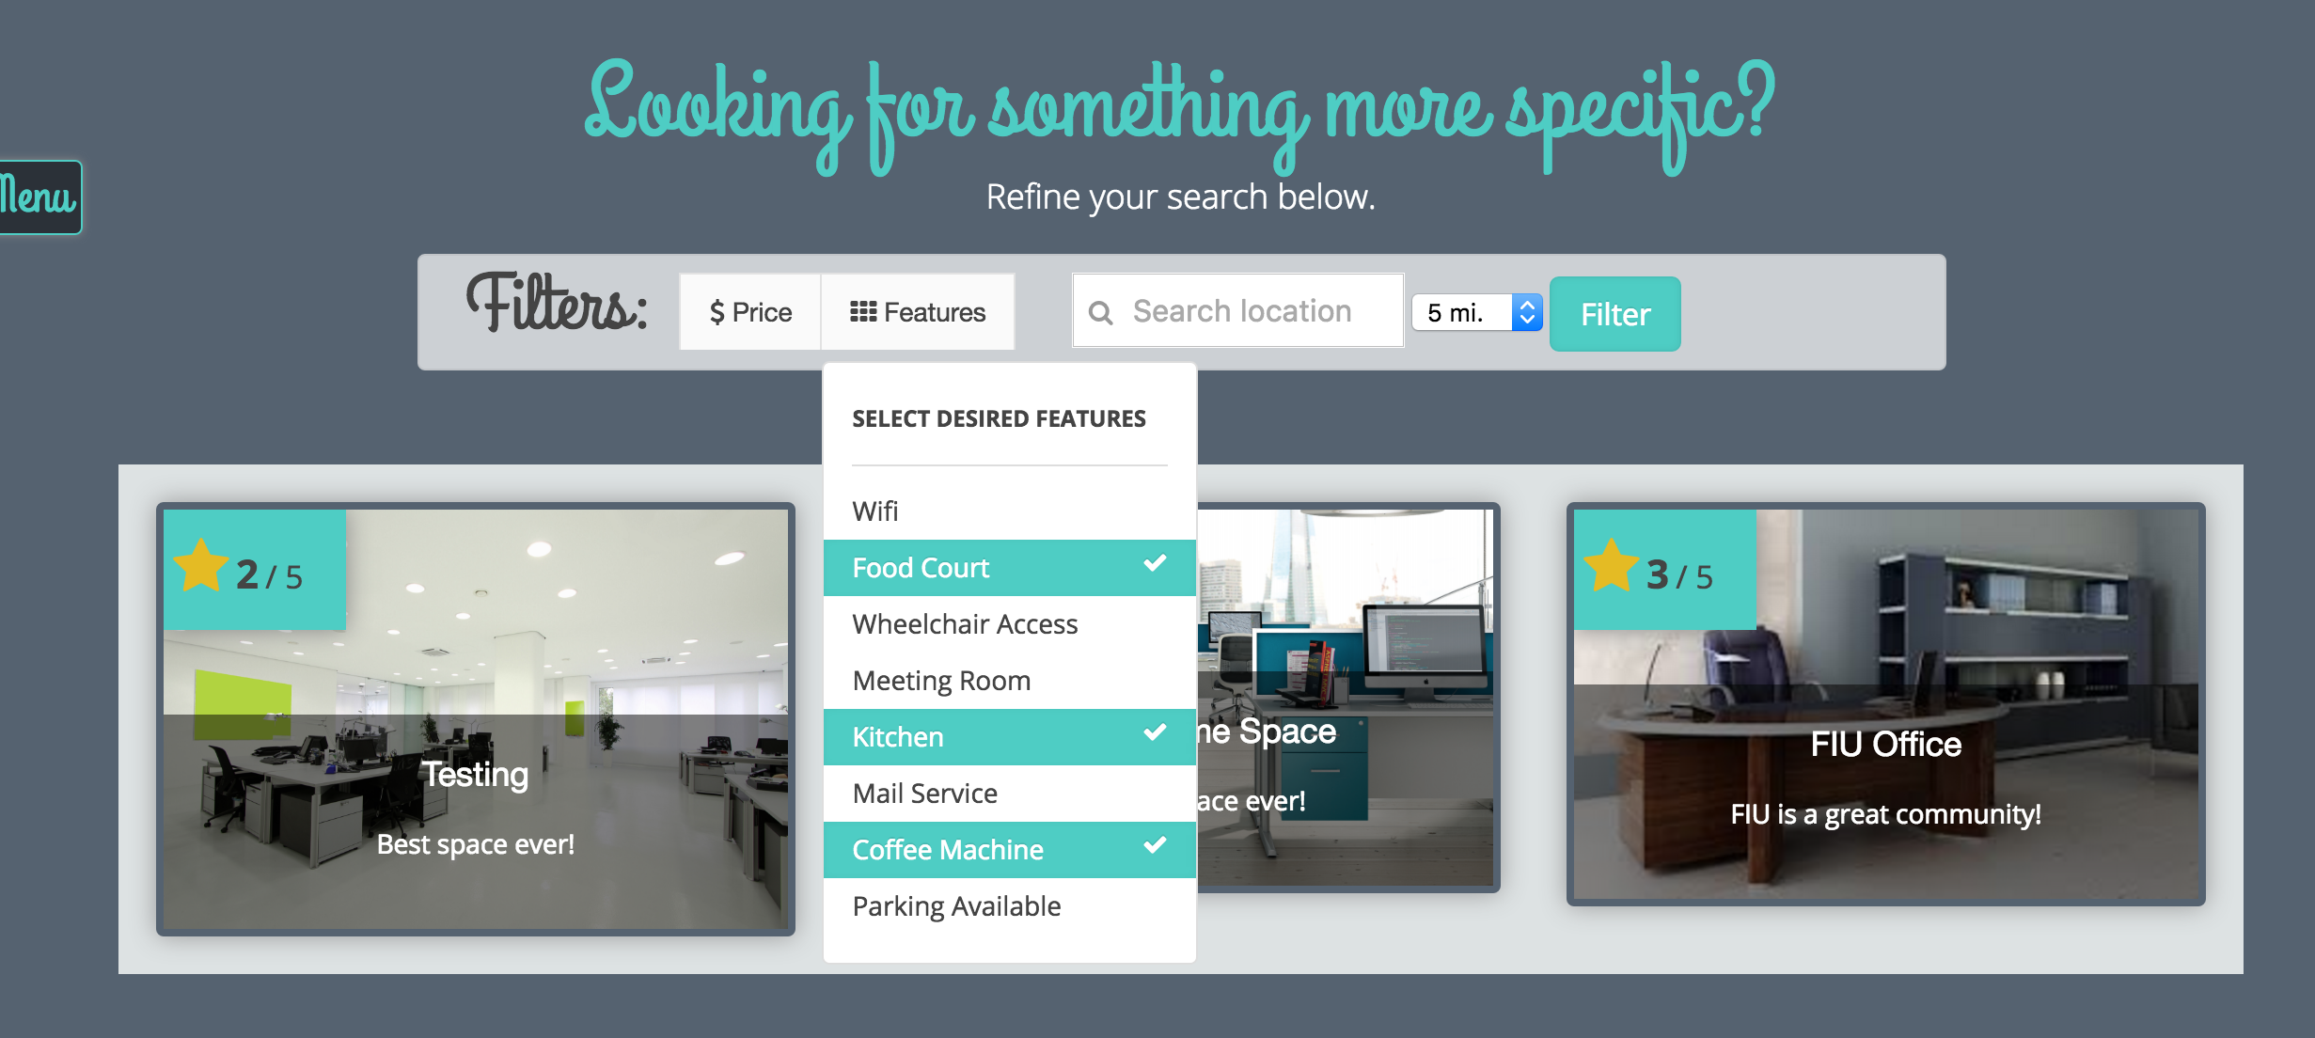

When you want to view the details of an office space, simply click on the image of the space.

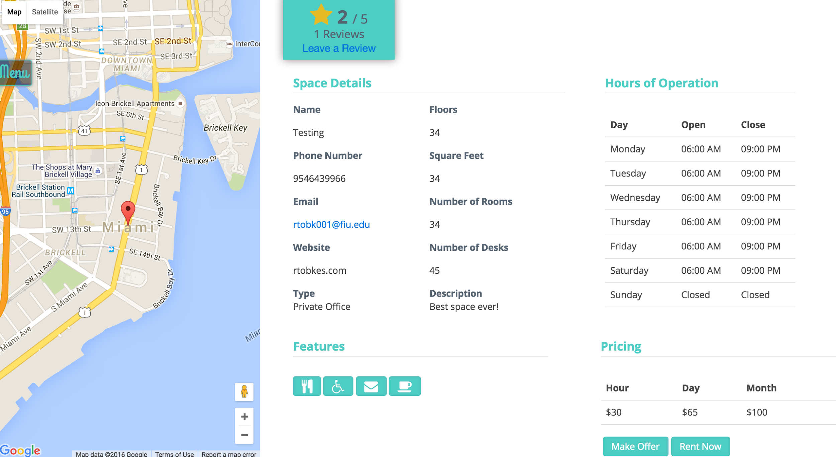

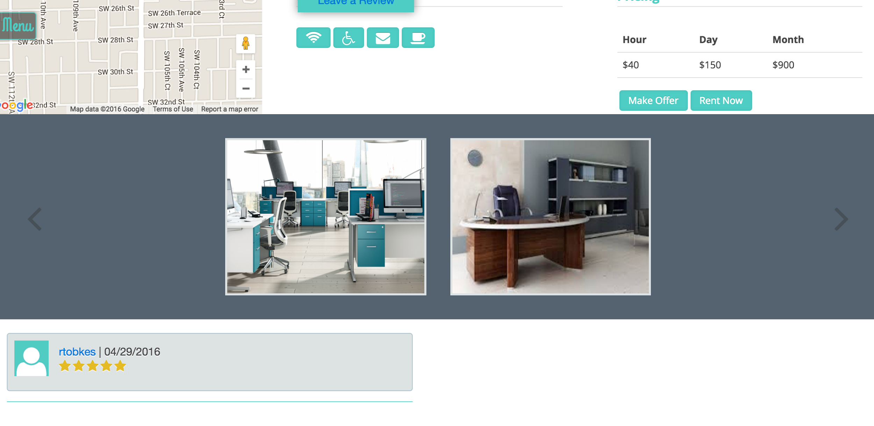

View photos of the space by clicking on them.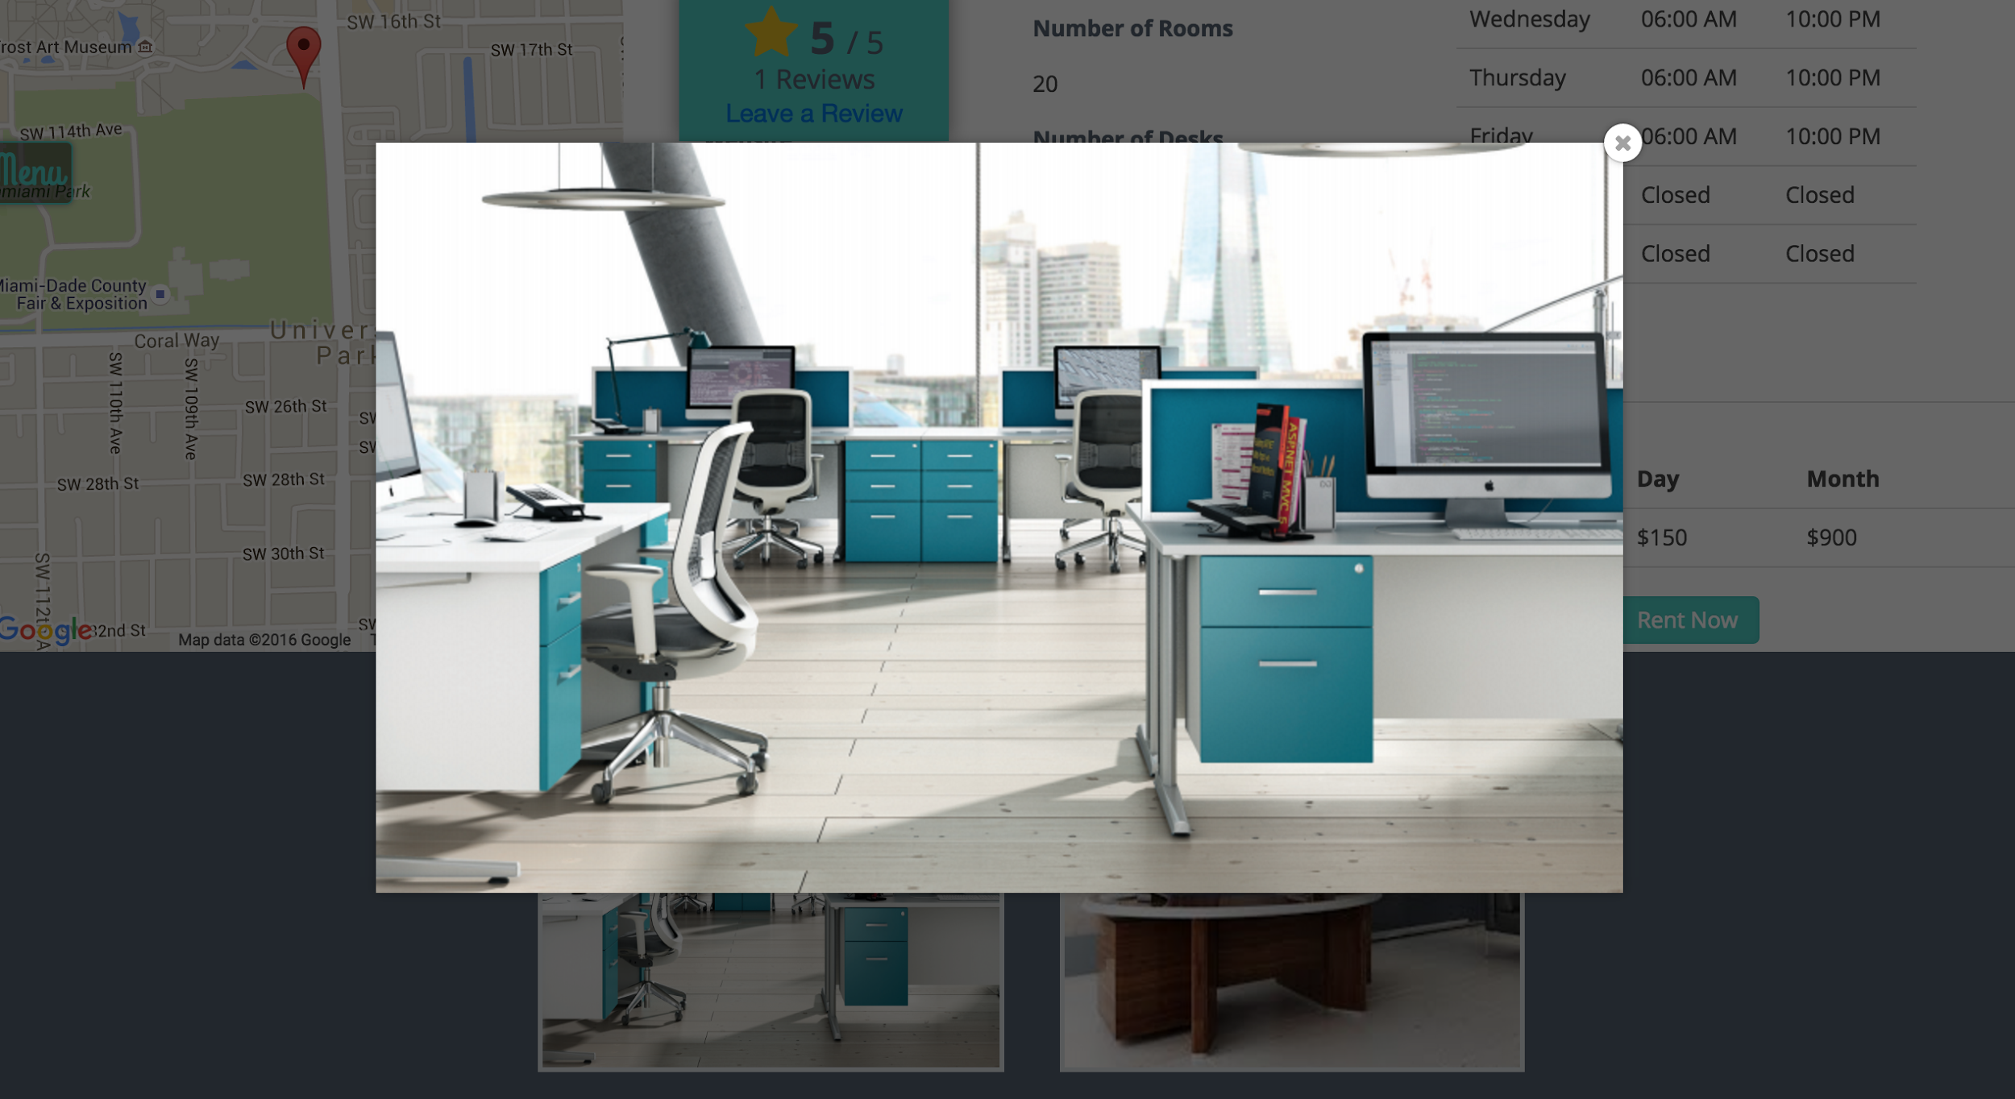

# 

# 

# 

# Sign-In

____________________________________________________________________________

Sign into the HyperDesk system by entering the credentials that you registered with. When done, click **Login**.

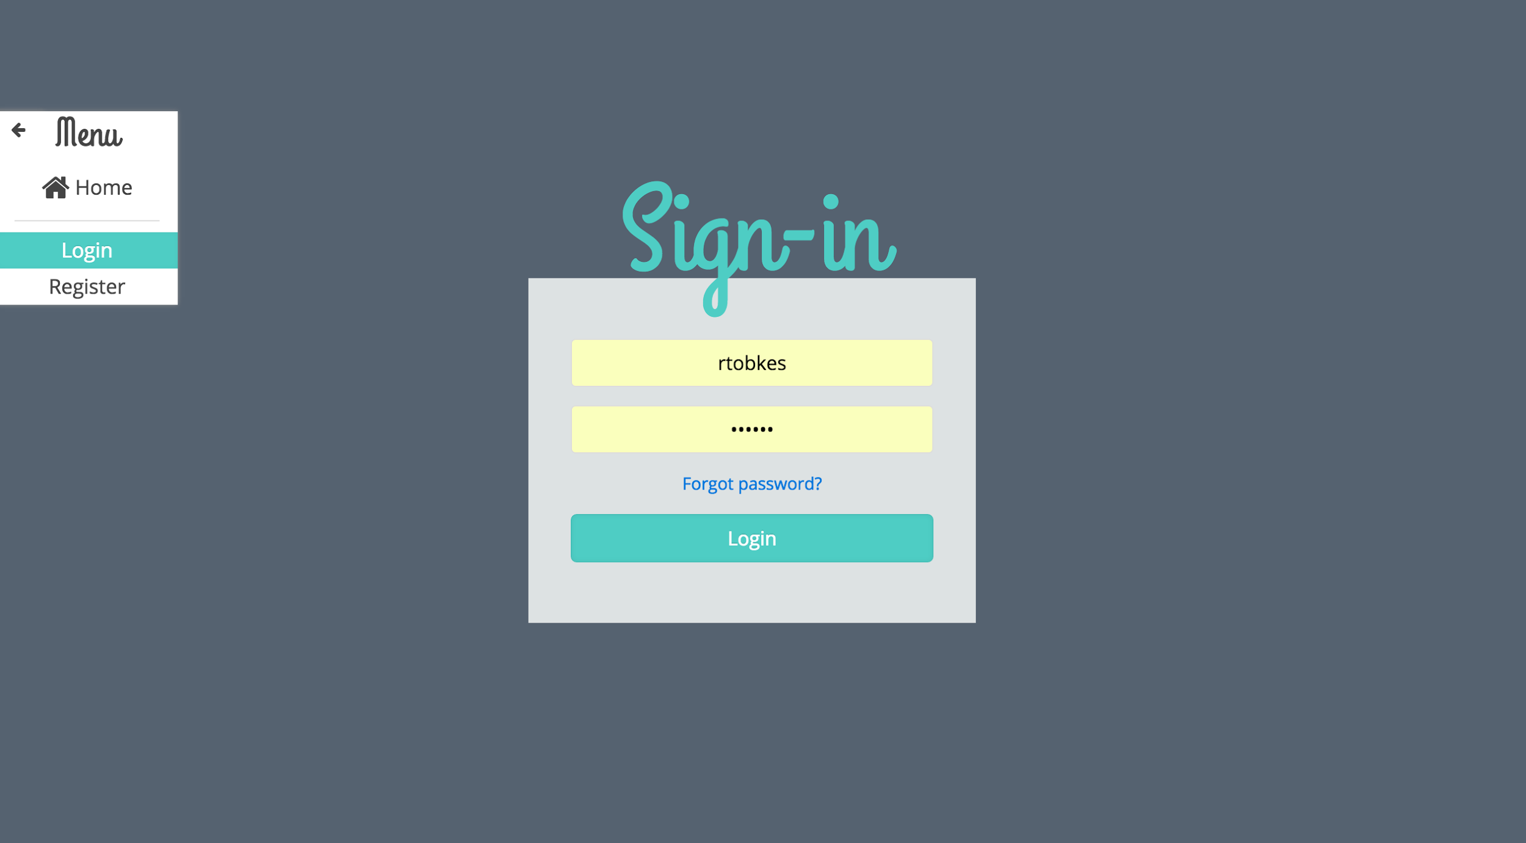

# List a Space

____________________________________________________________________________

List an Office Space by clicking **List New Space** on the **Menu** Tab.

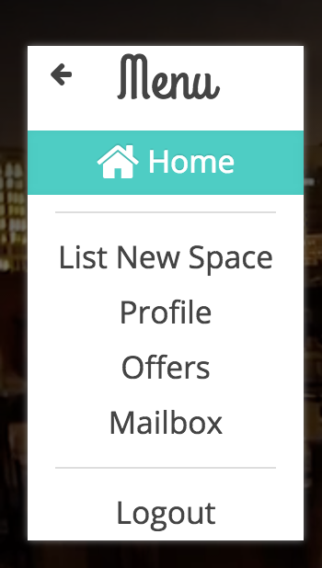

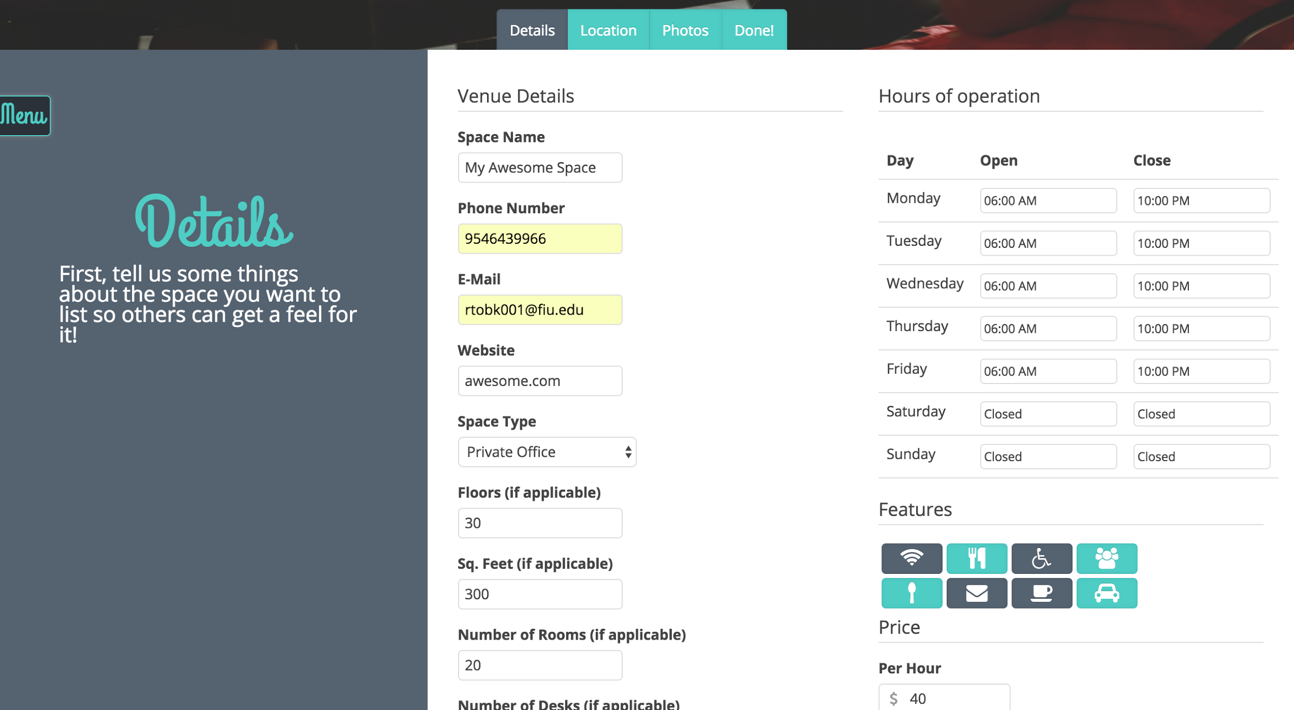

Fill out all of the required information. You can toggle between different sections of the form by clicking the **Details**, **Location,** or **Photos** tabs.

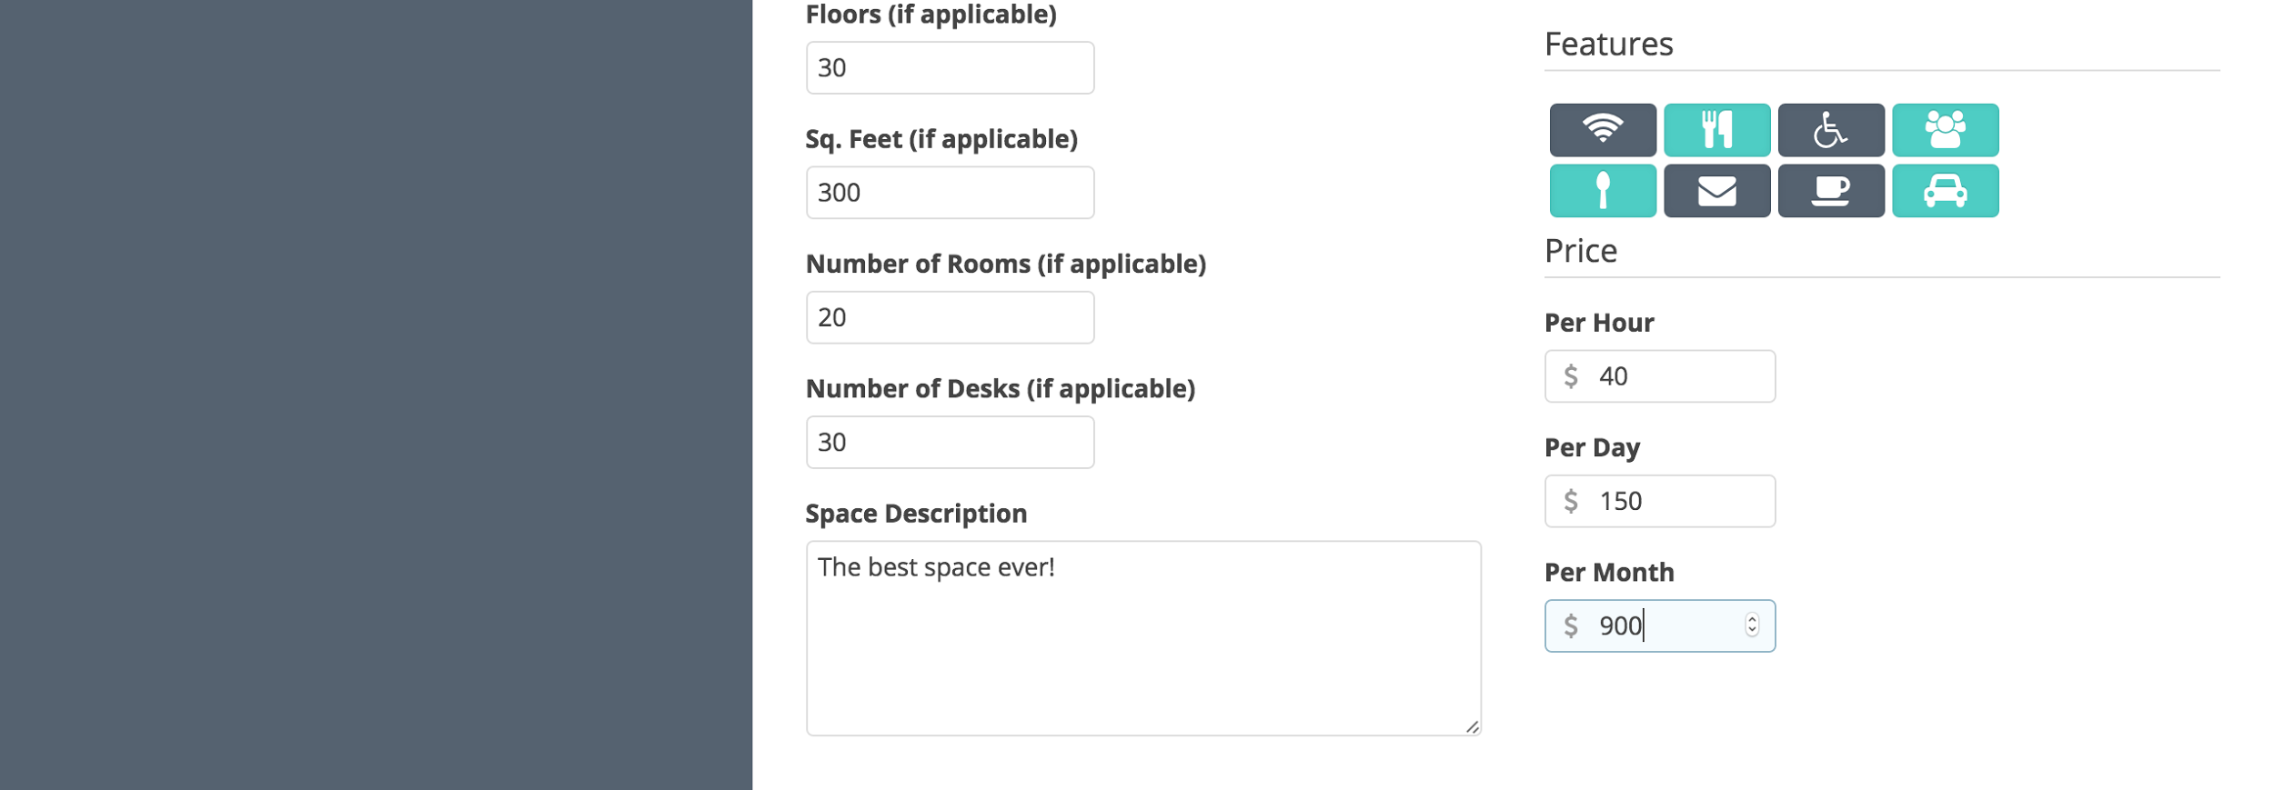

Choose the location of your office space by typing it into the search box.

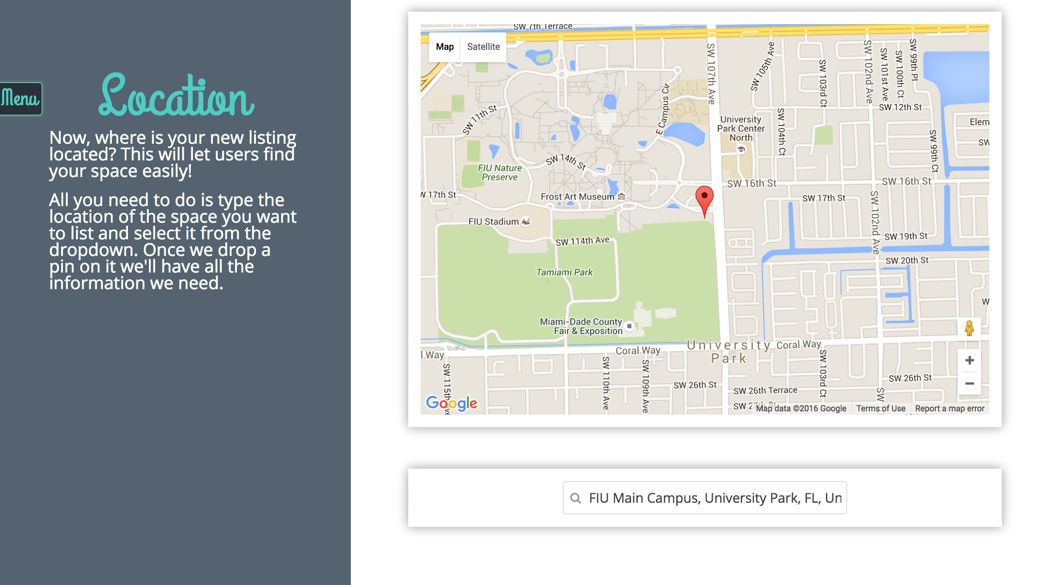

Select your office space images by clicking **selecting one** to upload one at a time, or you can also drag and drop to upload multiple at a time. If you want to remove an image, click the X mark on that image and it will be removed.

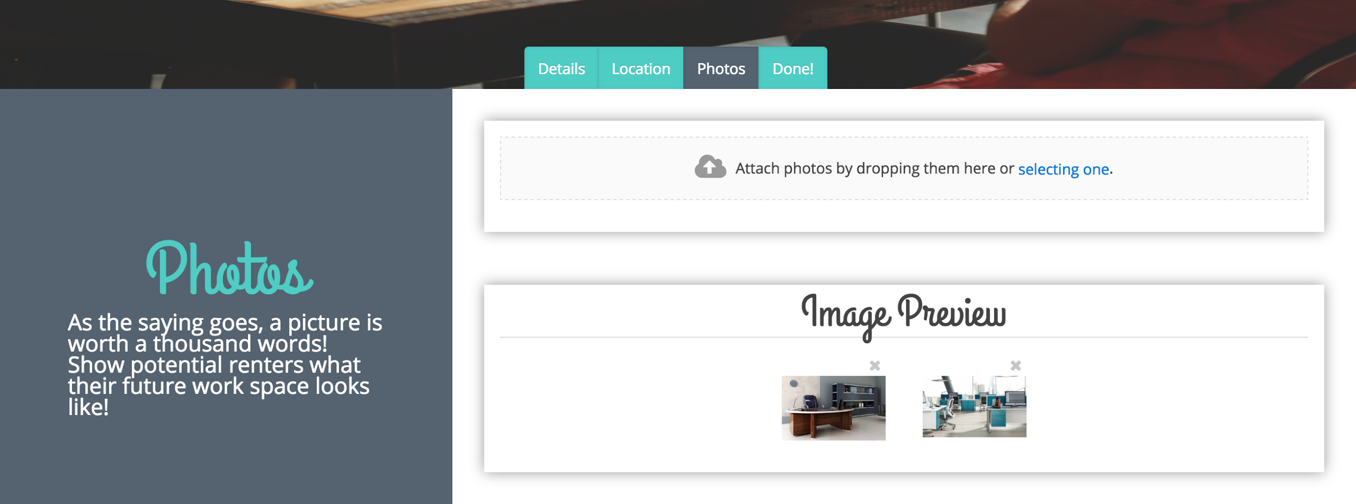

Once you are done filling out the form, click the **Done** tab.

# Set Up Bank Account

____________________________________________________________________________

When you attempt to list a space for the very first time, you will be taken to the following page.

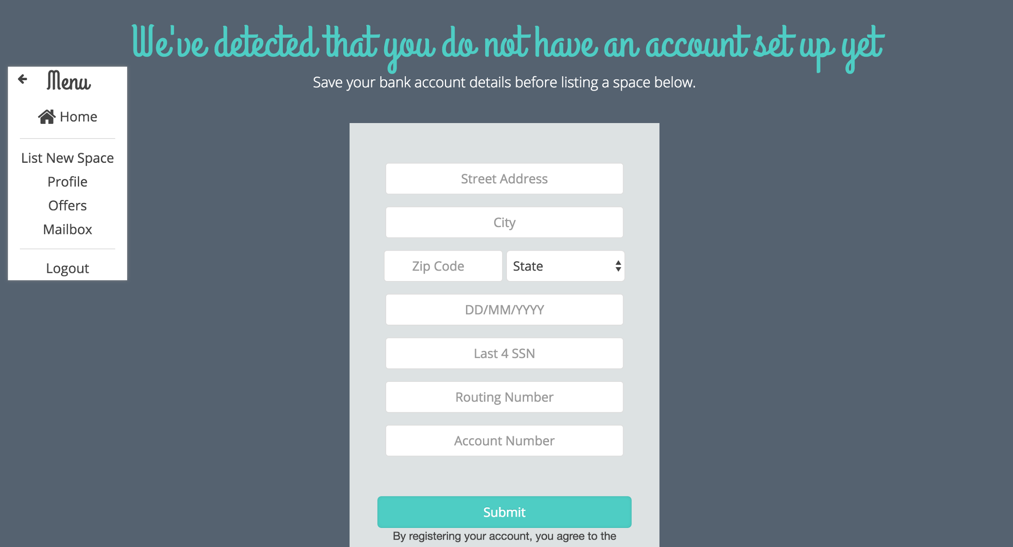

Fill out all of the details. And click submit when you are done. You will then be redirected to the new listing page where you can now list your space.

# Save Card Details

____________________________________________________________________________

Click the Account Settings button on the bottom left of your profile page:

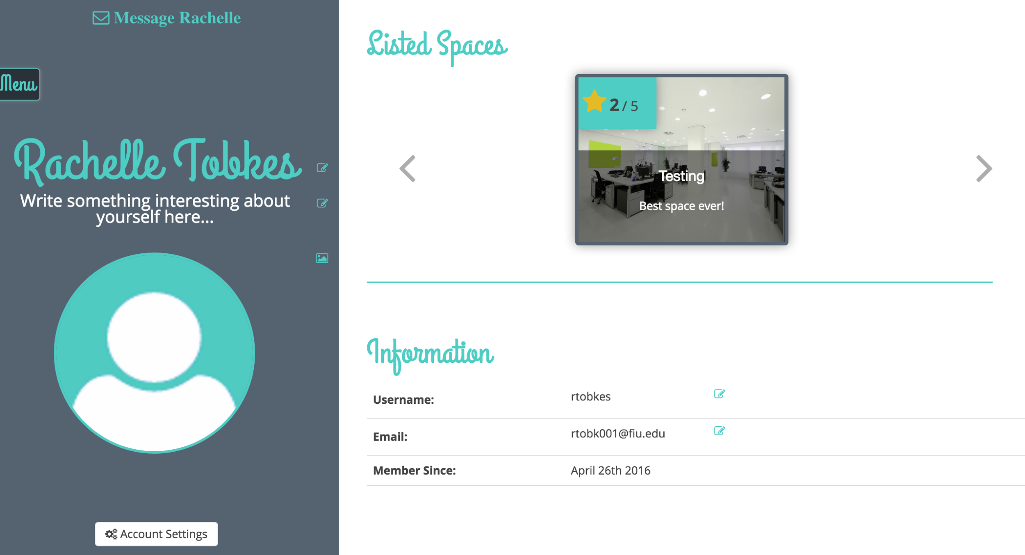

The following modal will be shown:

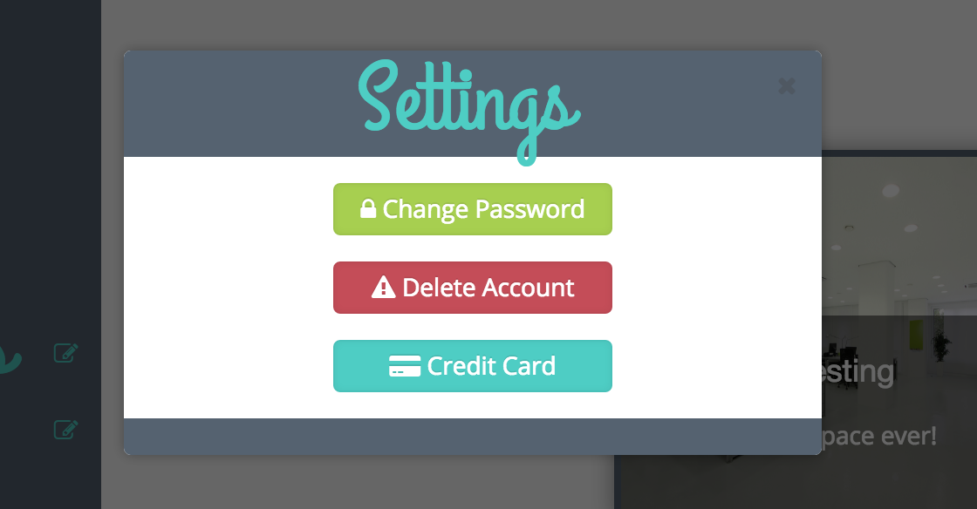

Click the Credit Card button. If you have previously saved your card details, then they will be shown below. Otherwise, a form will be displayed to enter your details. Here, if you want to update your card details, select the “Update my card information” option.

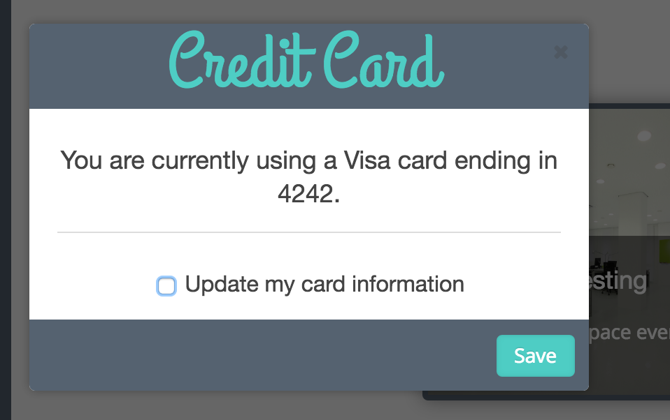

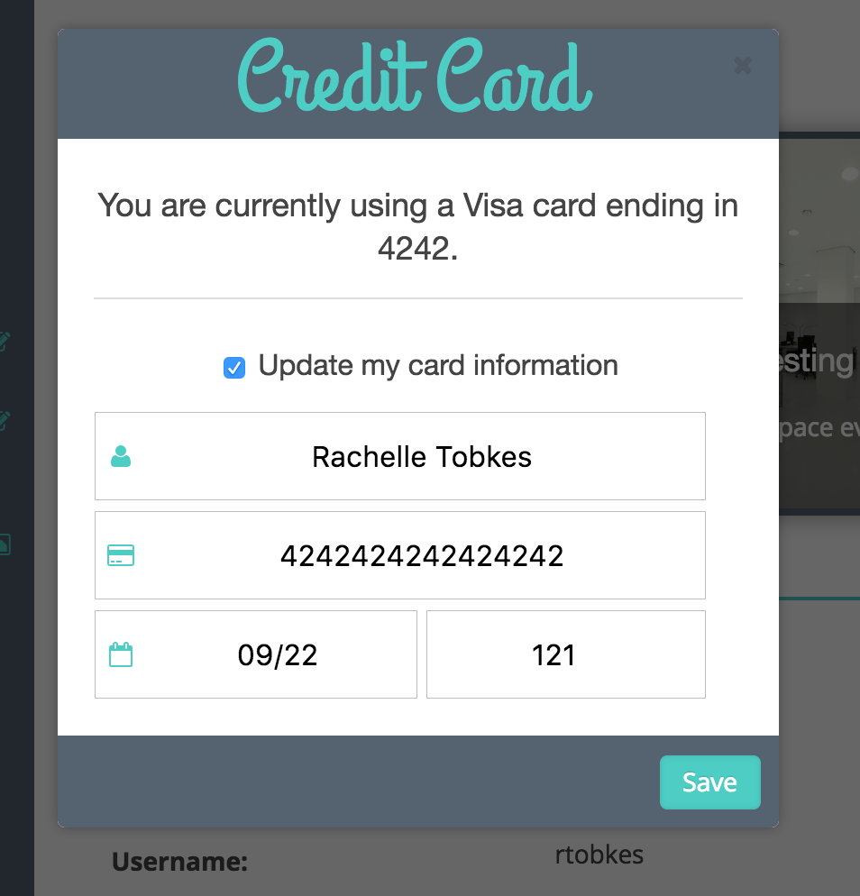

You can now enter new card details and click save when done.

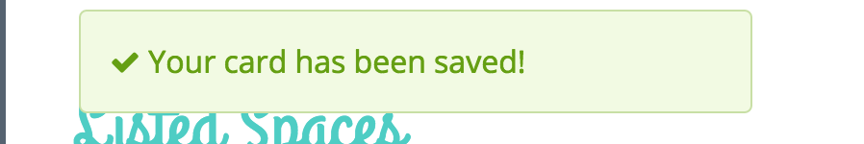

Congrats! You now have new card details.

# Accept/Decline Offers

____________________________________________________________________________

Click “My Offers” on the menu tab, and you will be presented with the following view:

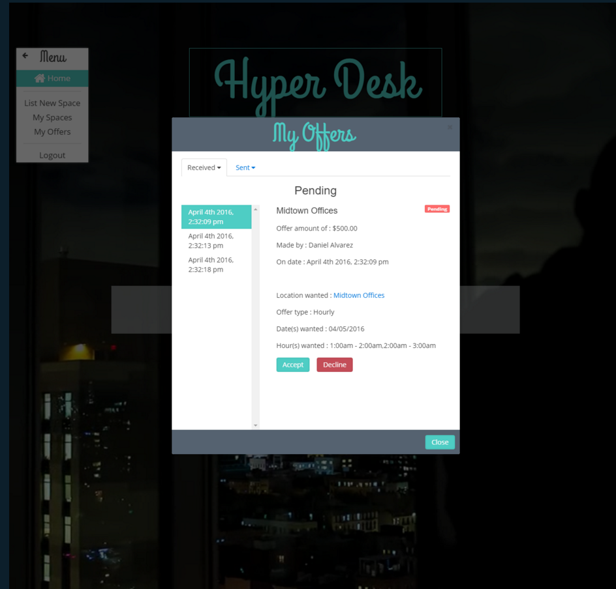

Click an offer, and if it is pending, you can select to either Accept or Decline it.

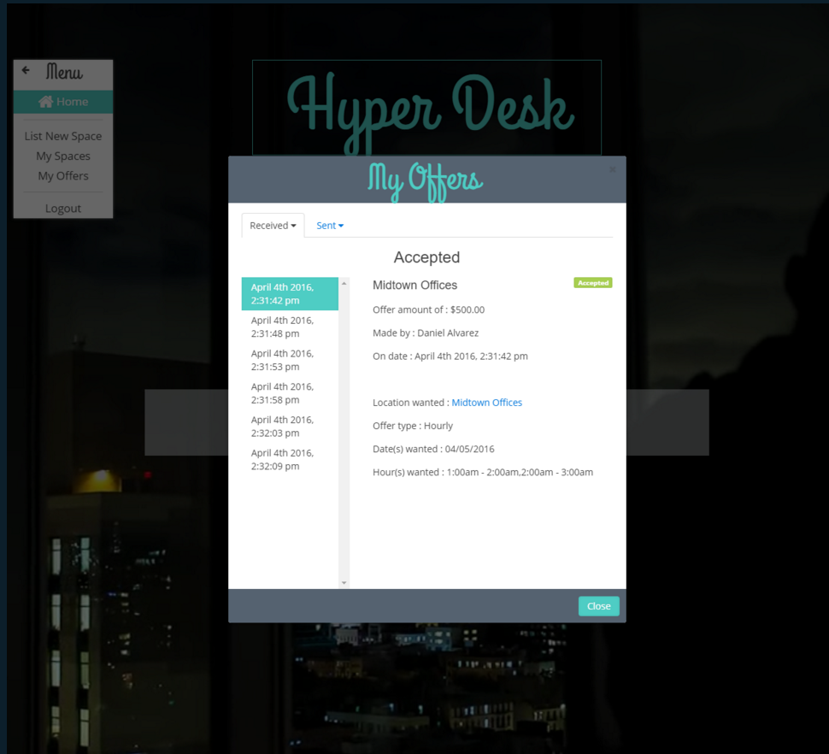

# Write a Review/Rate

____________________________________________________________________________

To leave a review for an office space, first make sure that you are logged in and that you are on the page of your selected office space and then click the **Leave a Review** link as shown below:

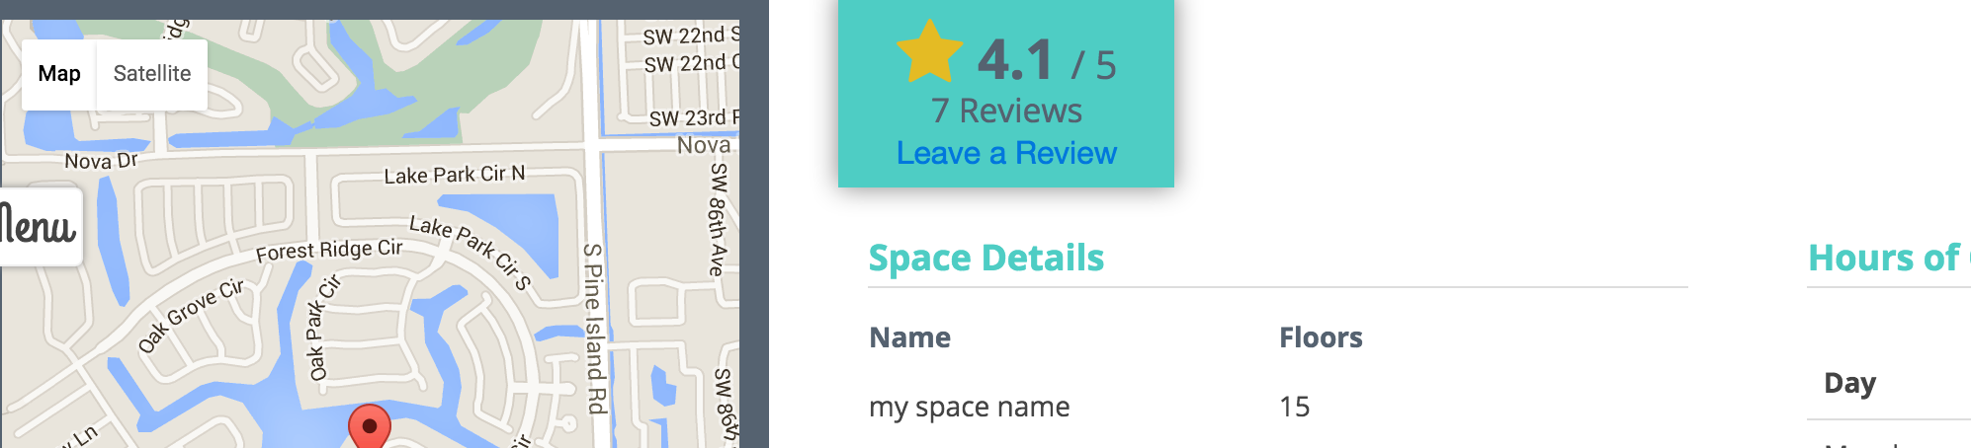

You will then be presented with the following page:

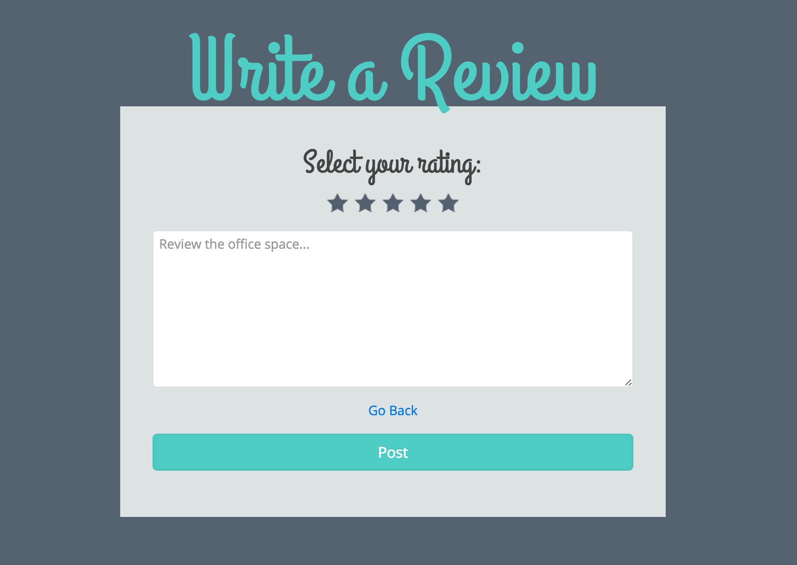

Hover over the stars to see what each one represents:

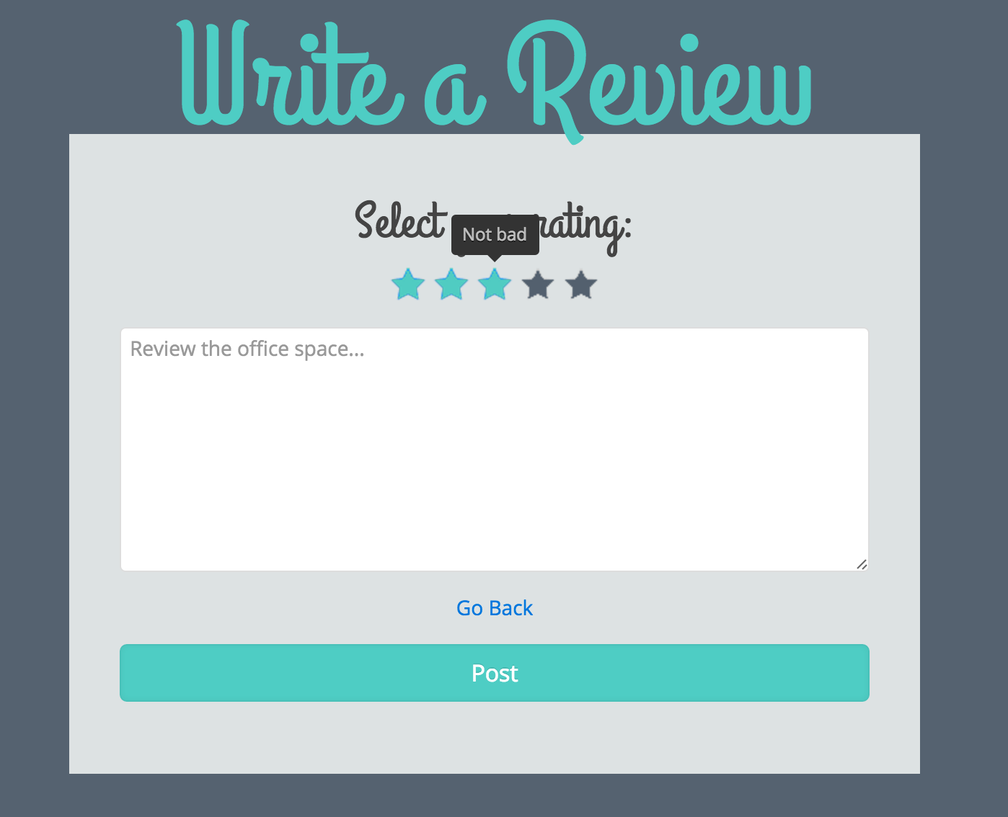

Fill out the information for your review. Please select a rating, but your written review is optional.

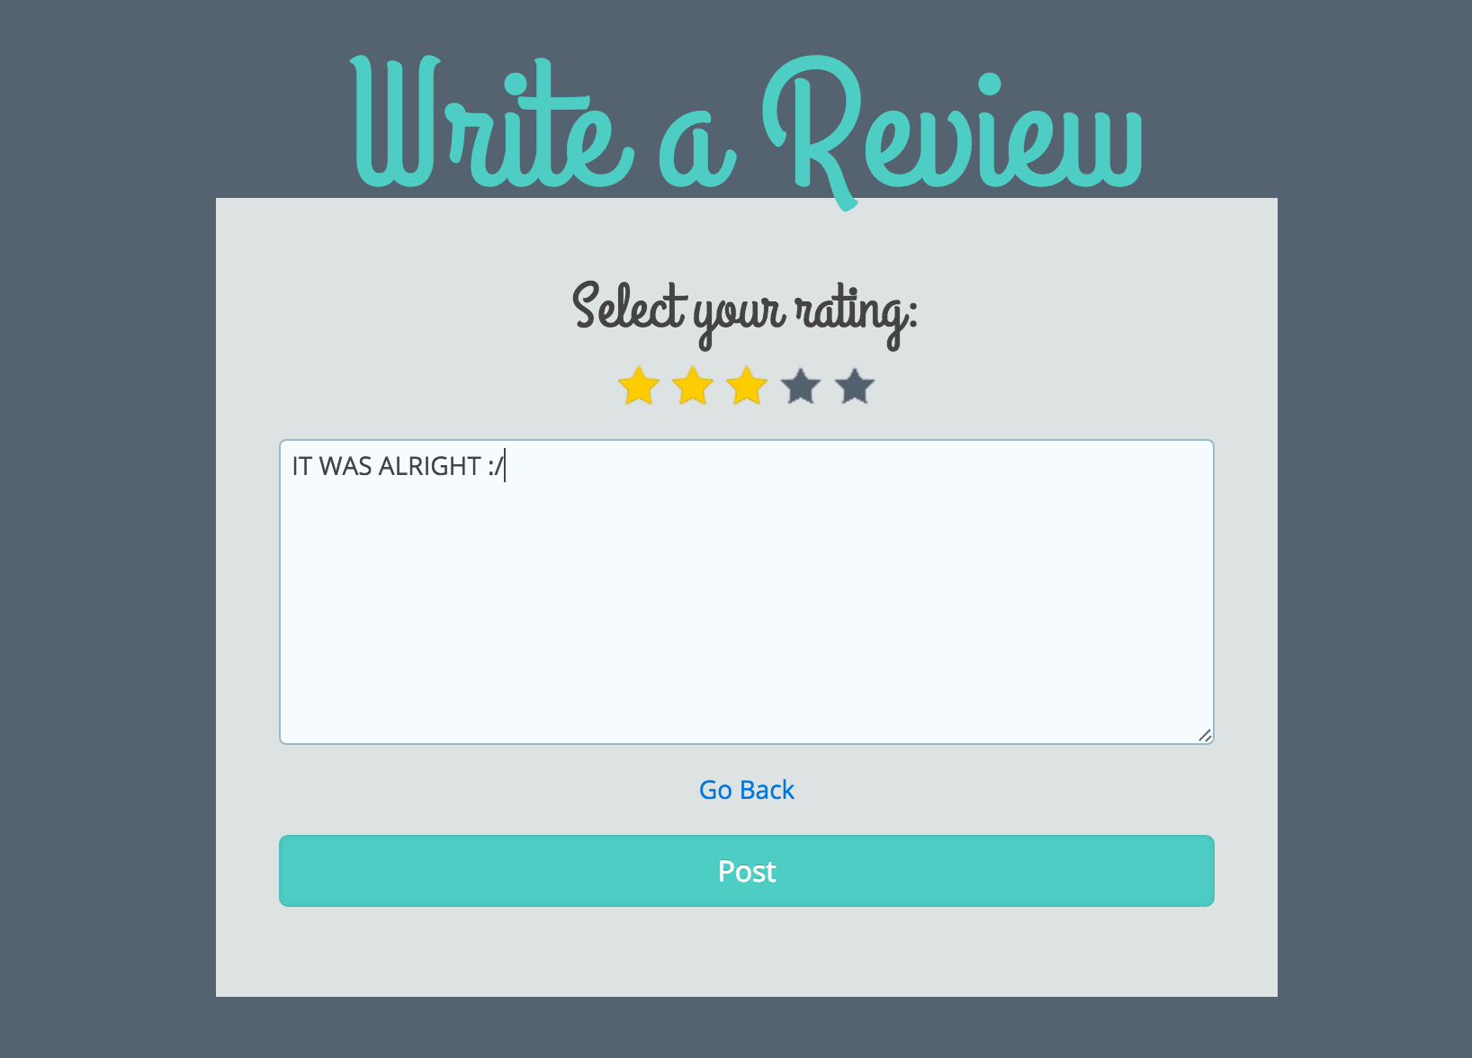

Click “Post” and your review will now be displayed on the office space page.

# Forgot Password

____________________________________________________________________________

Reset your password by first clicking the forgot password link on the Sign-in page.

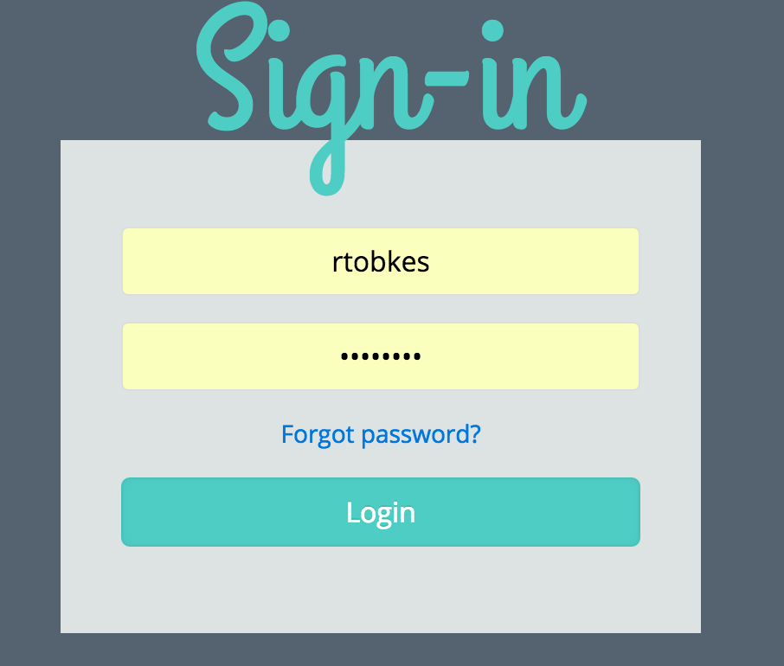

You will then be redirected to the following page, where you can enter your email address and click Reset.

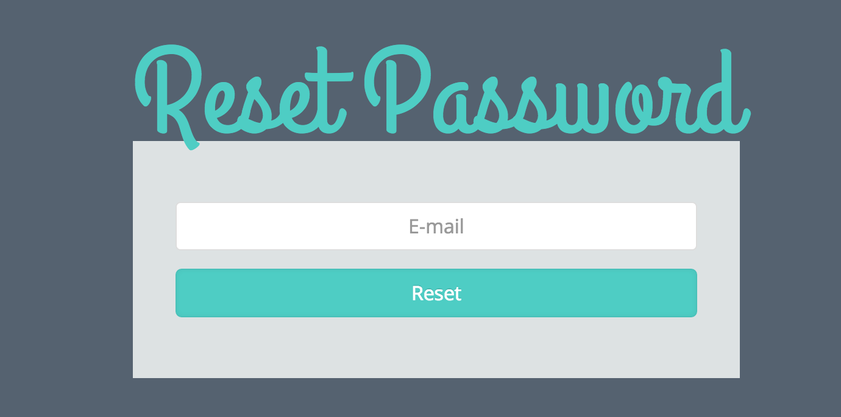

You will then be shown the following message.

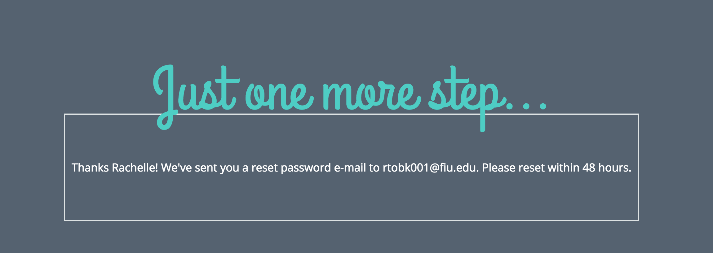

Check your email where you will see a message similar to the following:

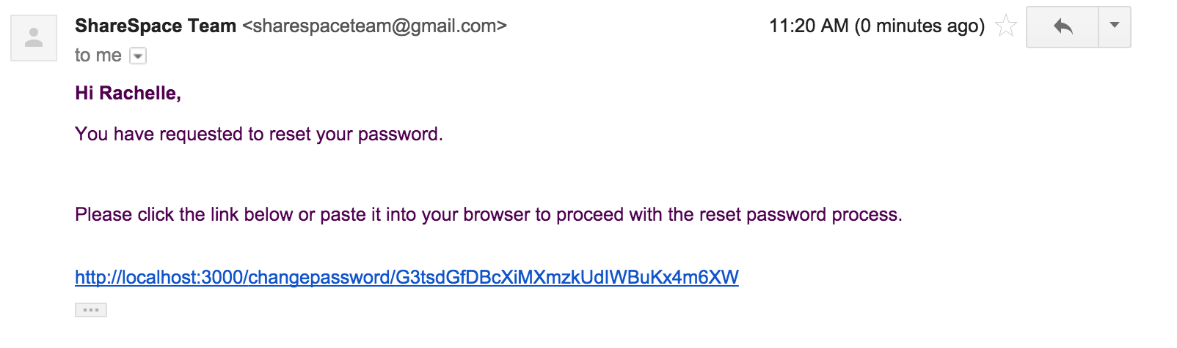

Click the link, and you will be taken to the change password page. Enter your new password, confirm it, and click reset.

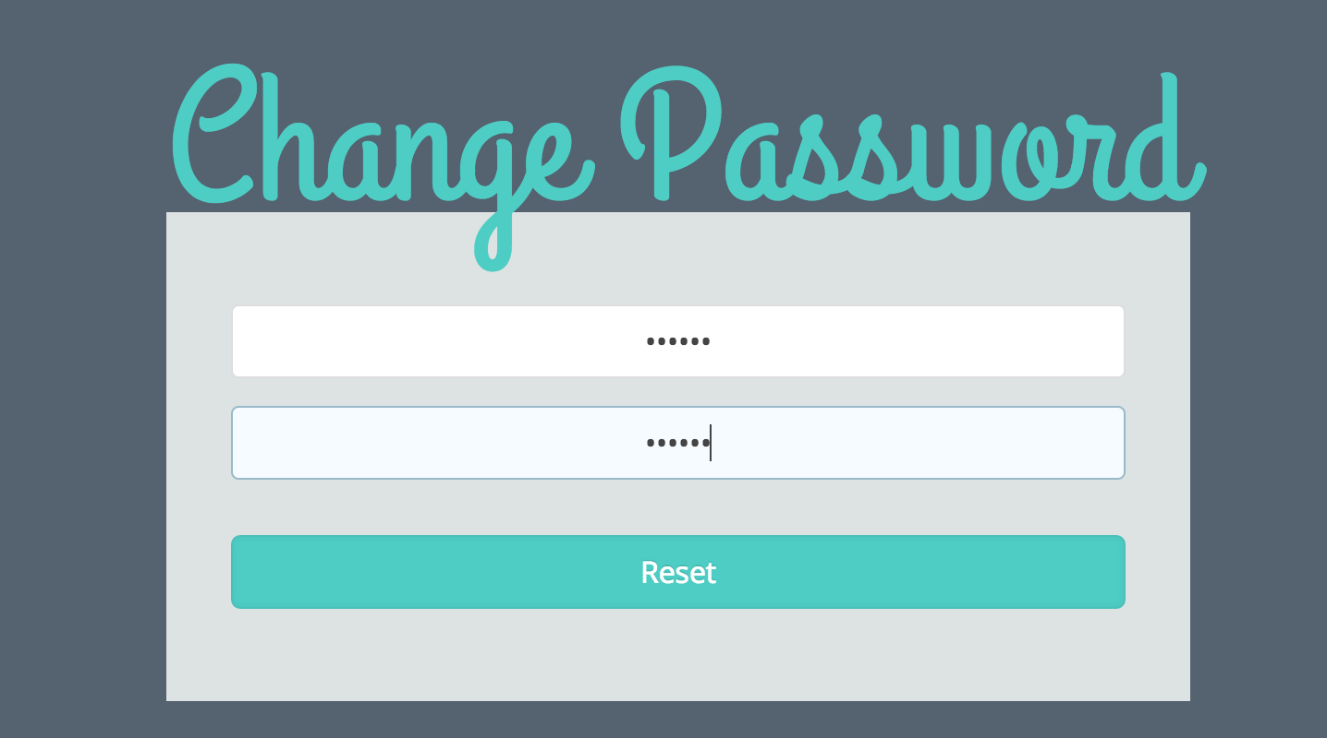

Congratulations! Your password is now changed and you can login with the new one.

# Make an Offer

____________________________________________________________________________

Click the “Make an Offer” Button on the bottom right of the space page that you are viewing.

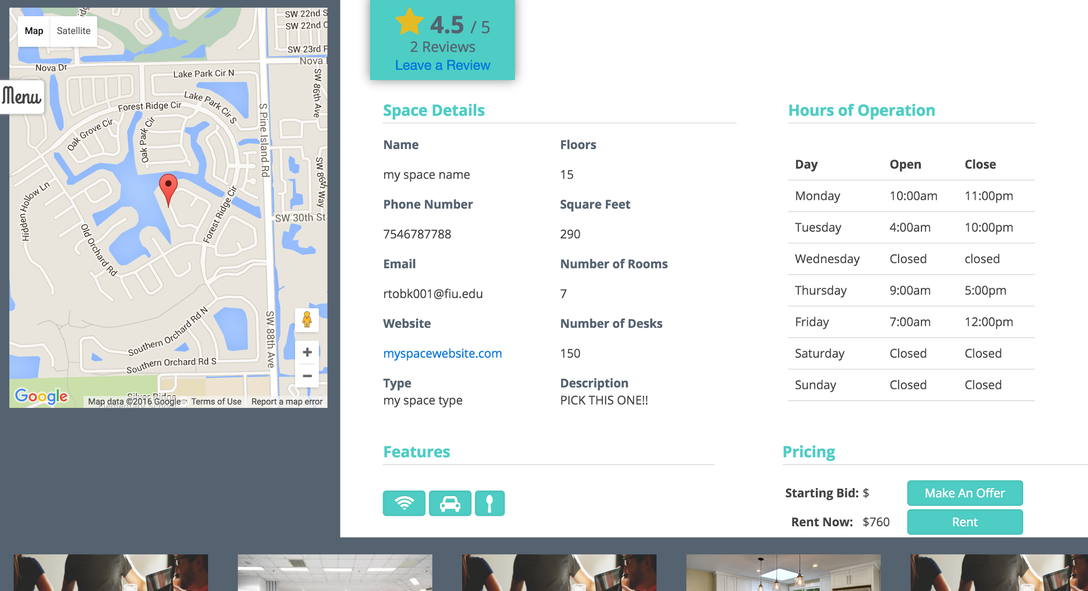

The following form will be displayed:

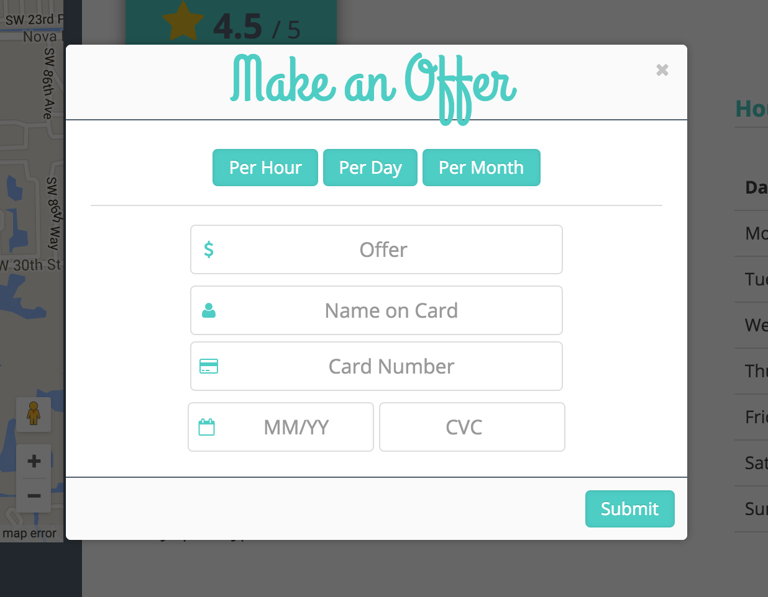

Select per hour, per day or per month.

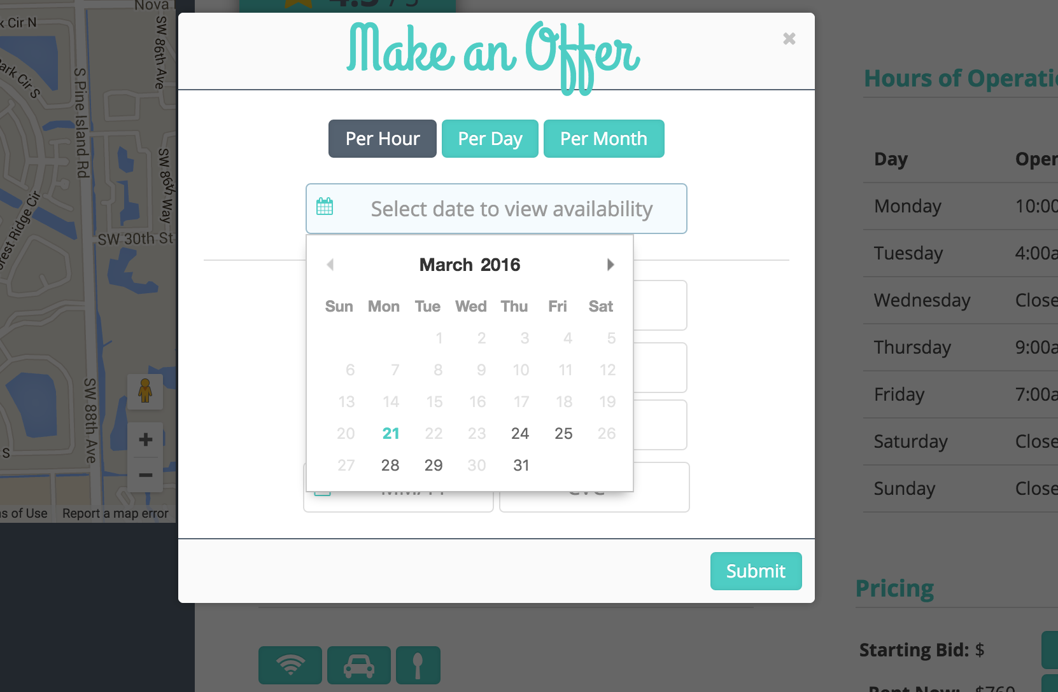

Select a date on the calendar to view its availability. Dates that are disabled are either dates that the facility is closed, or dates that have already been reserved.

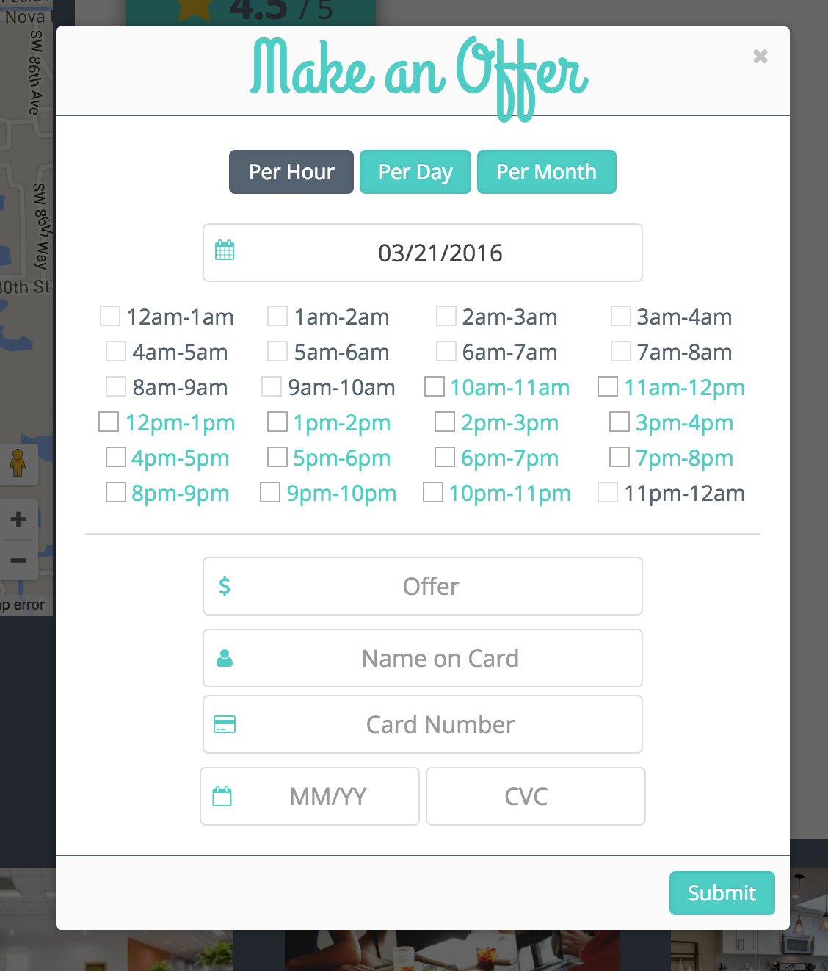

Hours shown in black are unavailable and cannot be checked. Hours in blue are available.

Switch between buttons to choose per hour or per month instead.

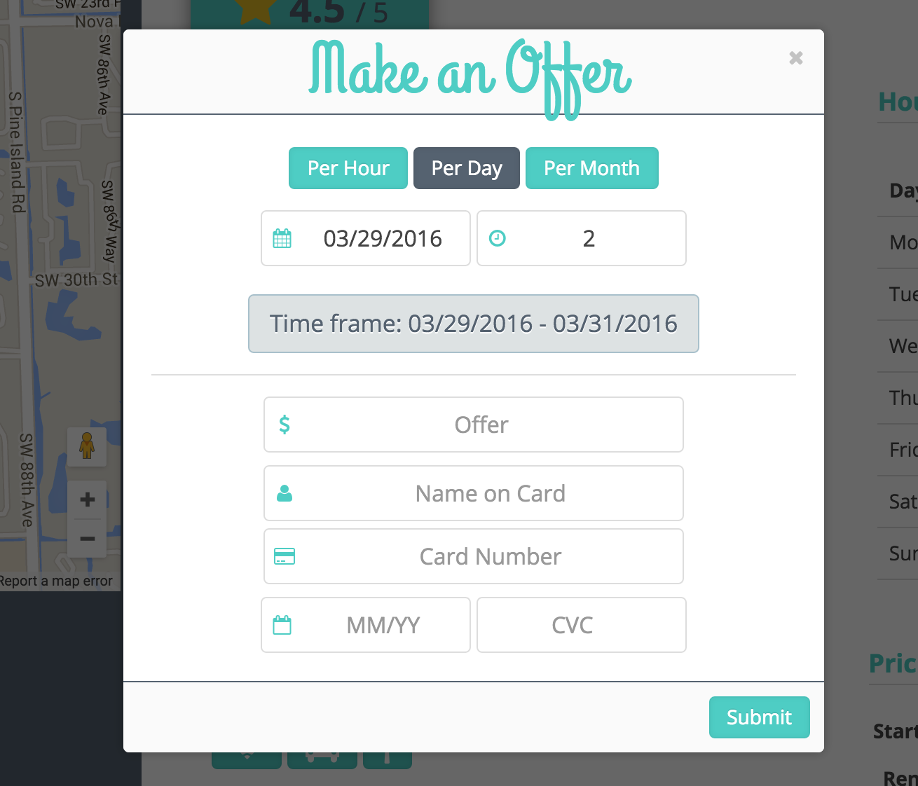

Fill out the form and click submit, you will be presented with the following notification:

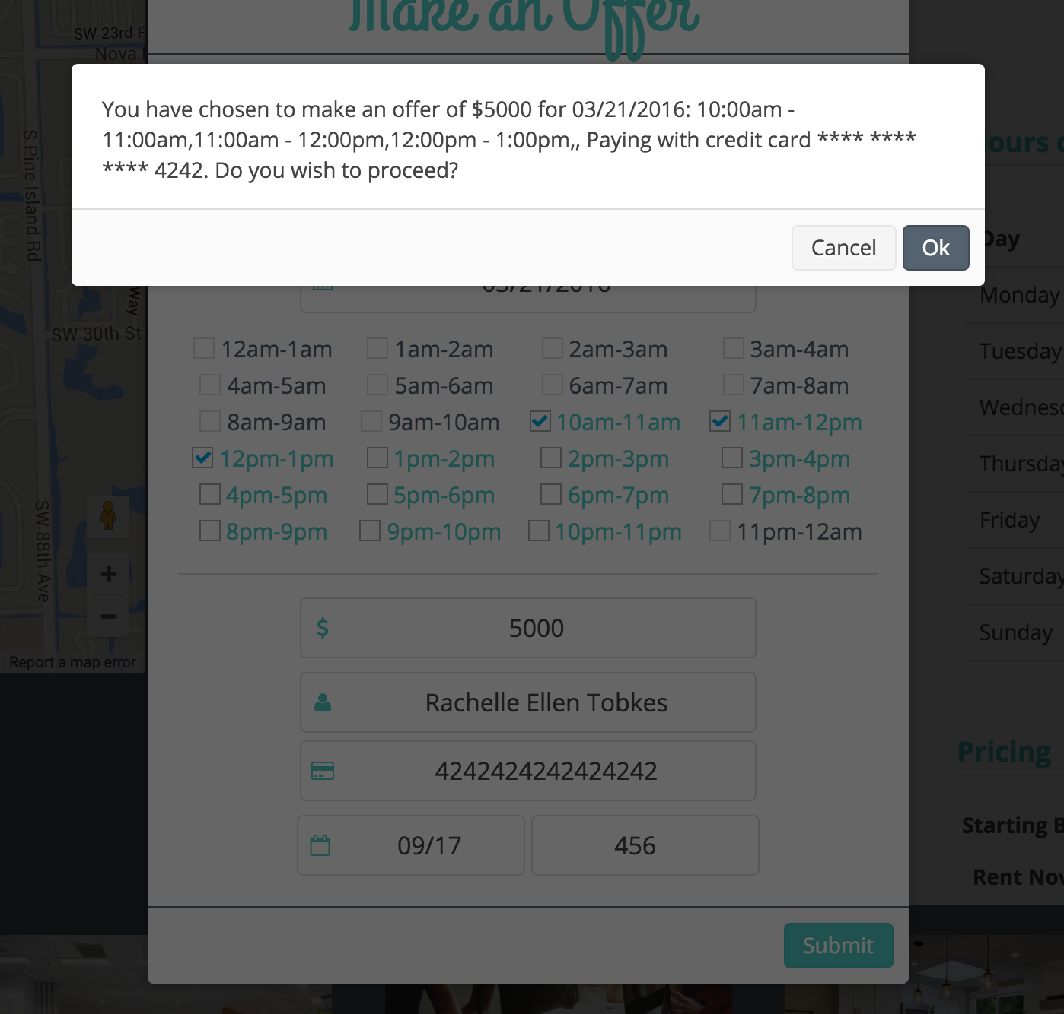

Confirm and you are done!

# Message User

____________________________________________________________________________

Begin by selecting **mailbox.**

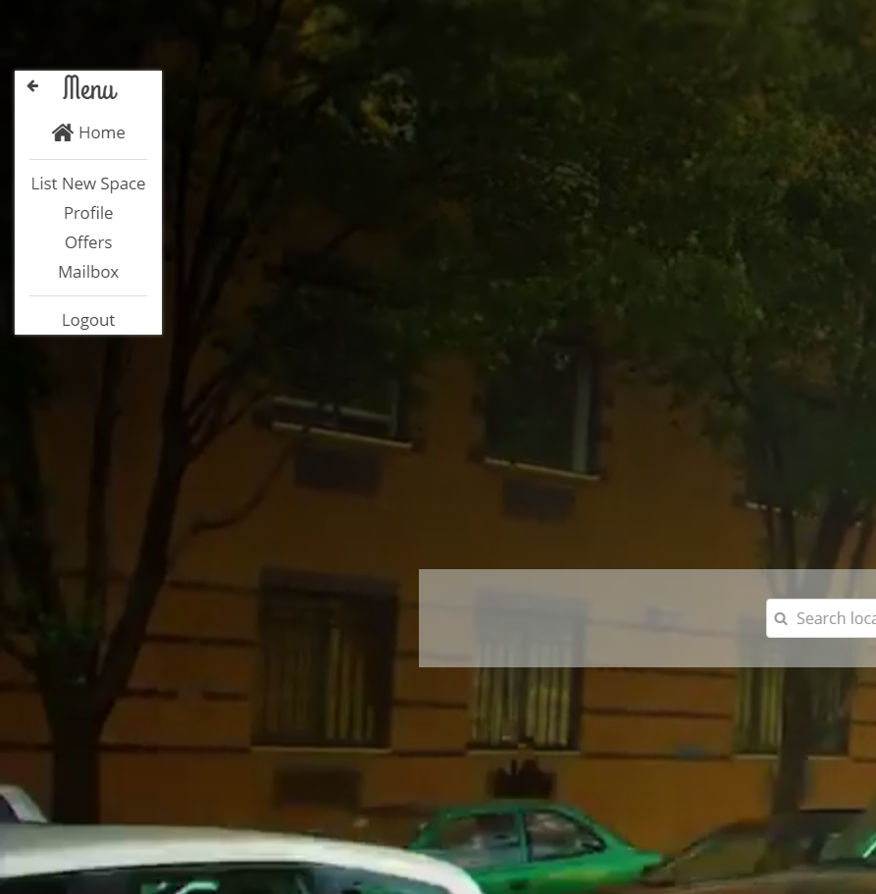

To send someone a message, type their username, the subject of the message, and the message body. Then click send.

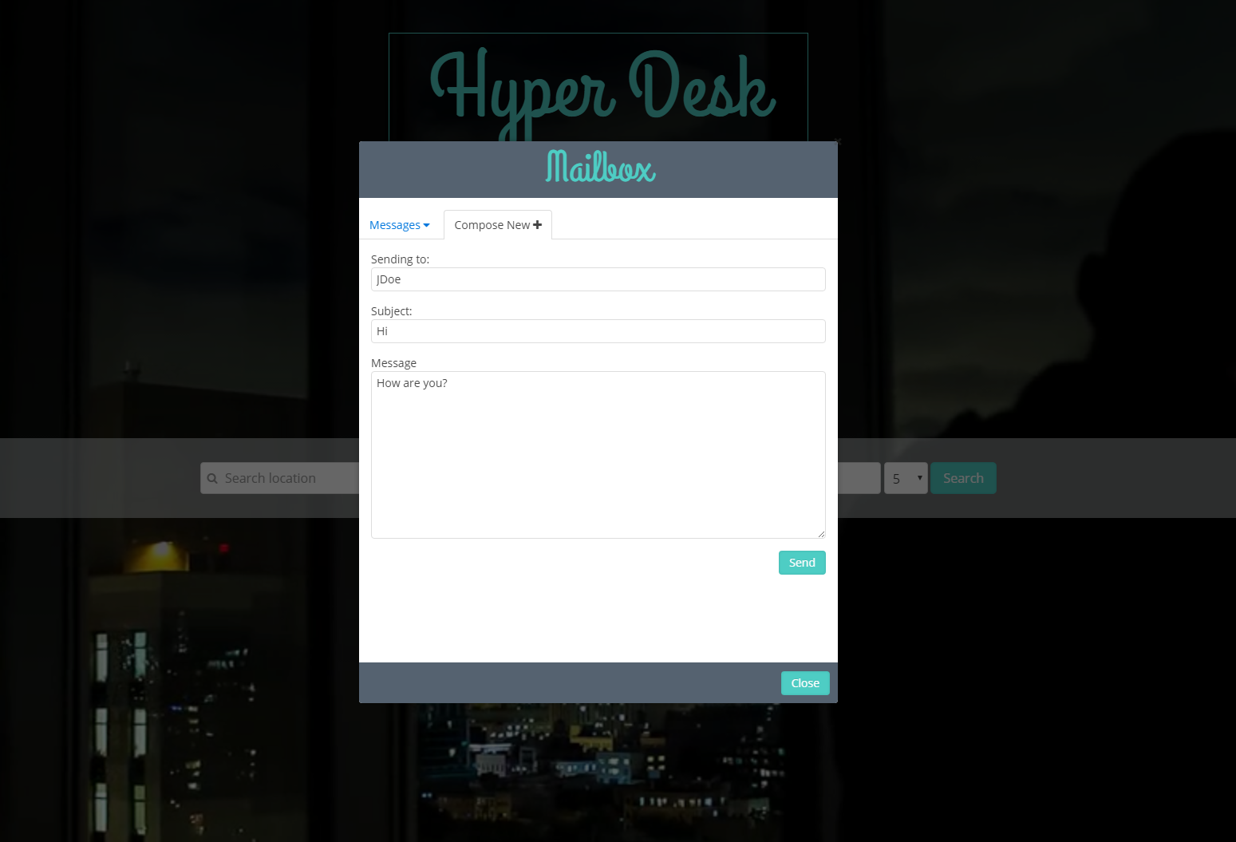

To view your messages, click Messages then Inbox or Sent. Selecting a message from the left will display it on the right panel.

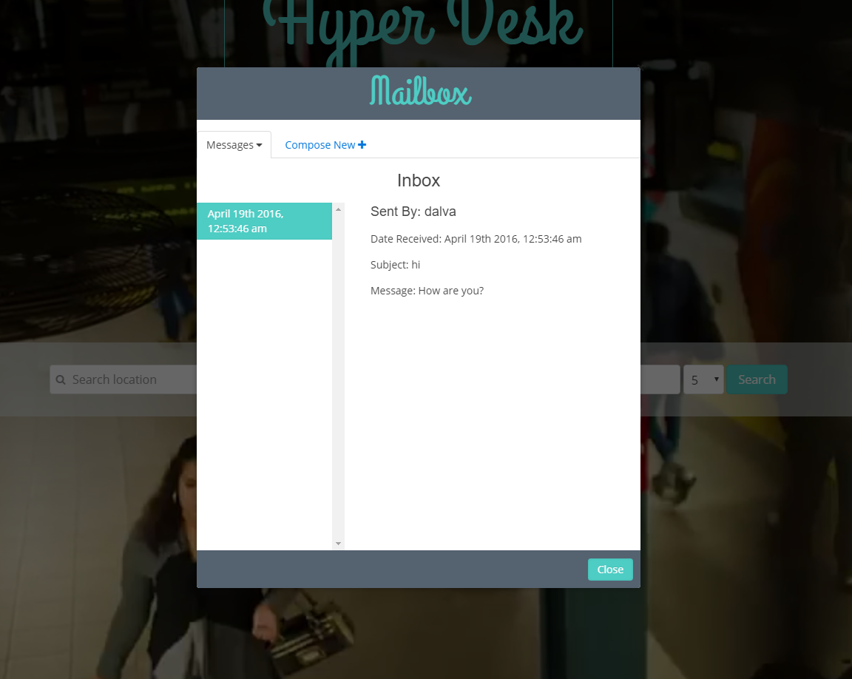

Reply or delete messages by right clicking to open the context menu, and selecting your option.

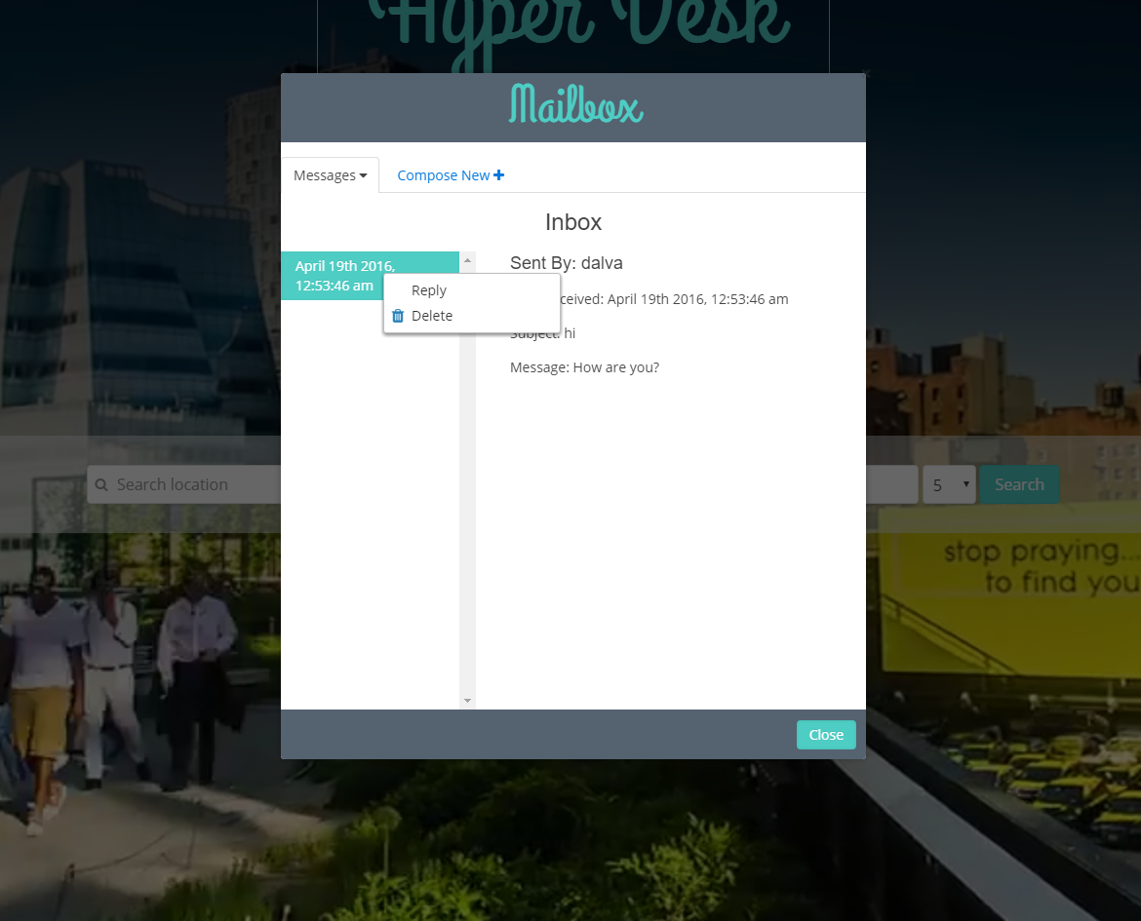

# Edit Profile

____________________________________________________________________________

Once you are logged in, you can navigate to your profile by clicking the Profile link on the menu bar.

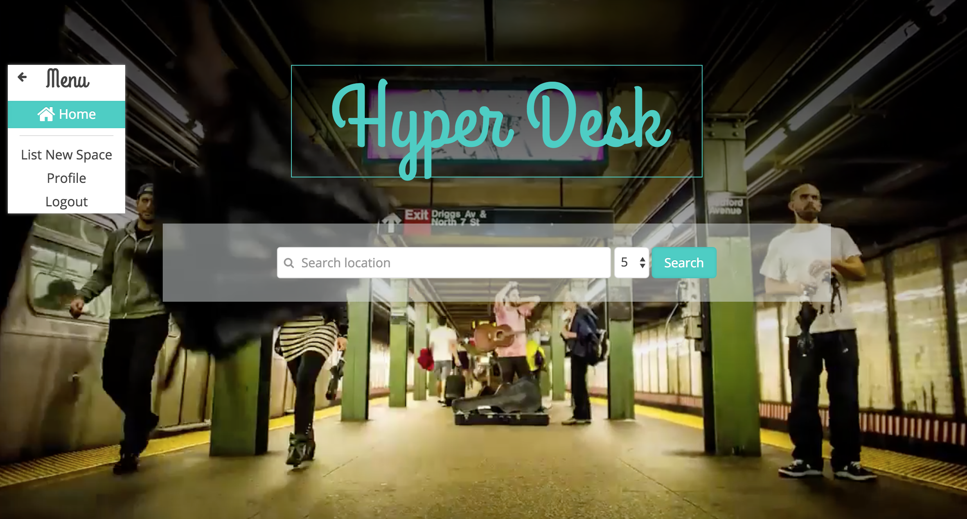

Initially, your profile will look like this:

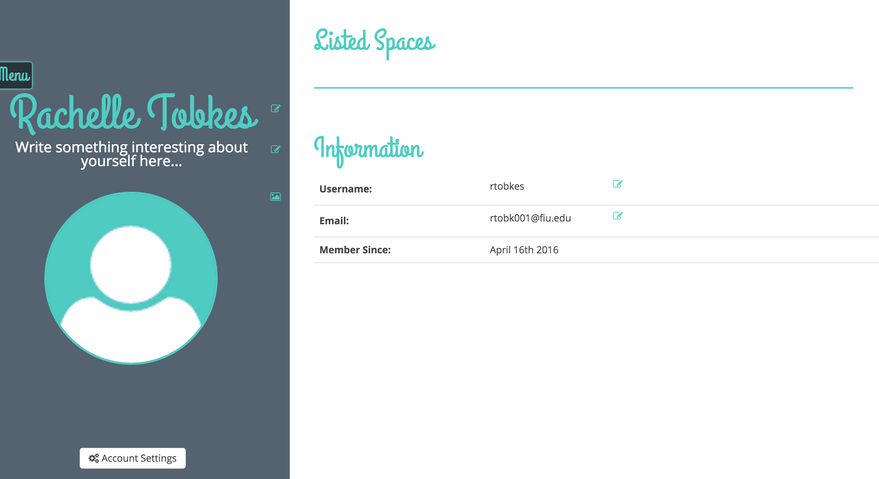

You can edit the fields by clicking the icons to the right of them.

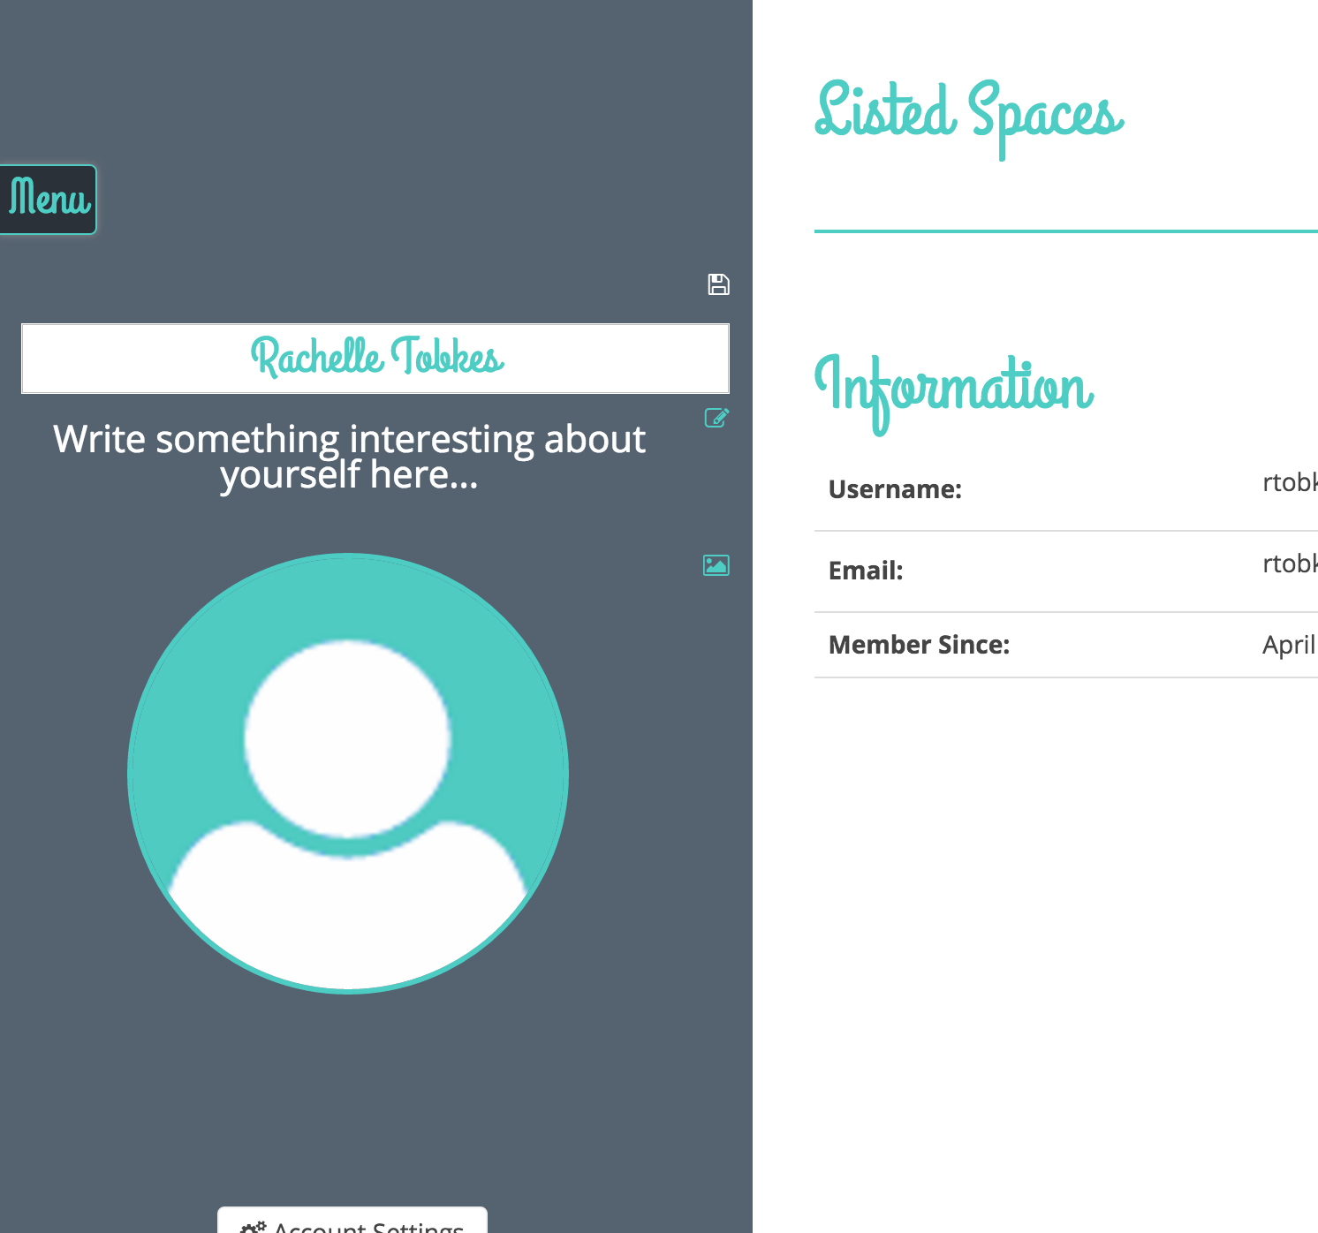

Edit the field, and then click the save icon to the right of the field.

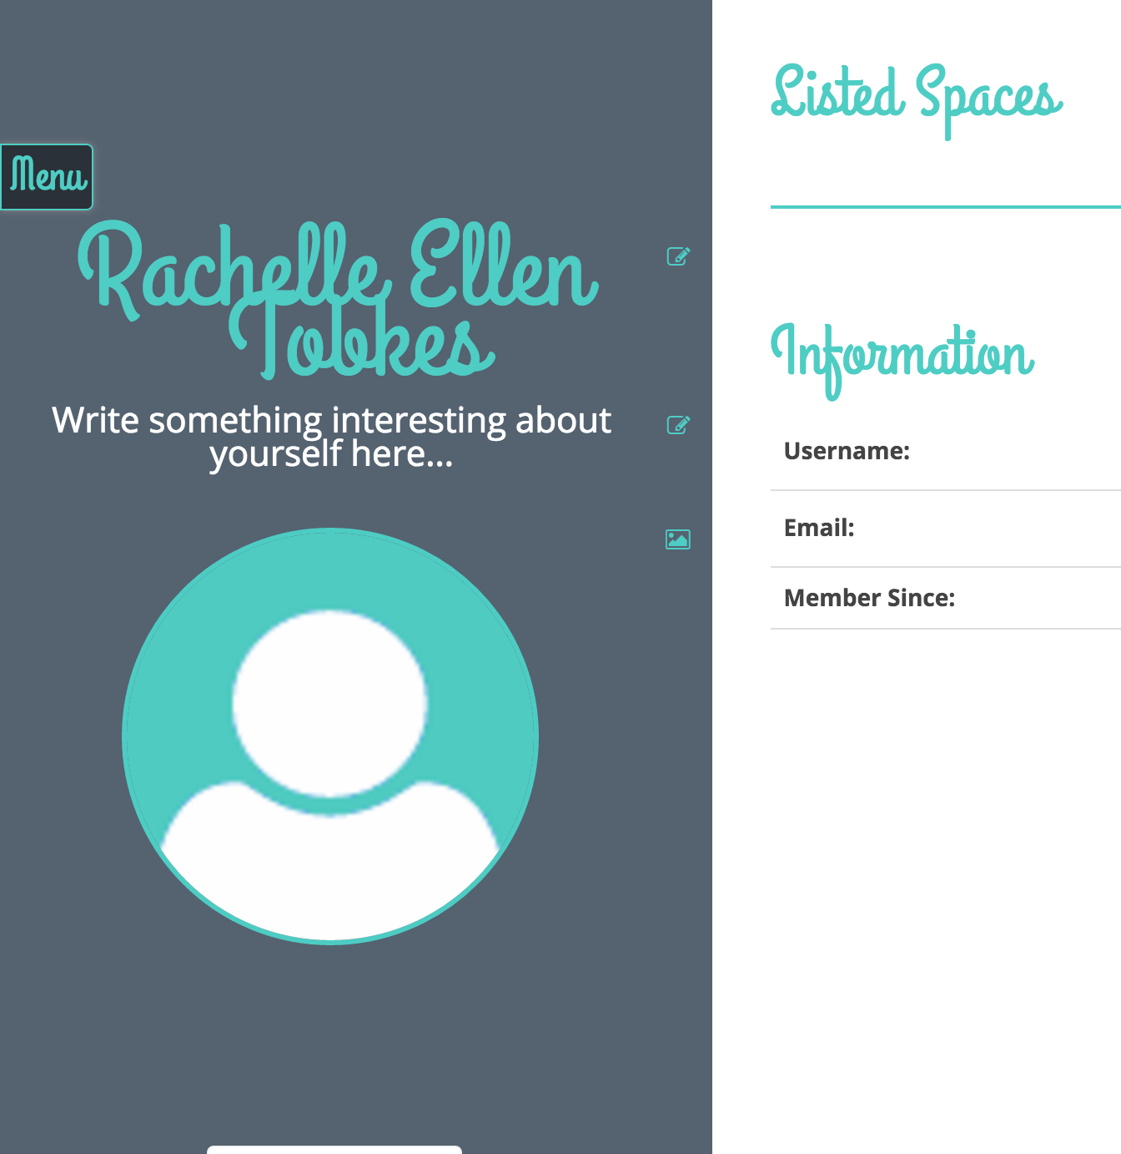

When you list spaces, they will be added under the “Listed Spaces” section.

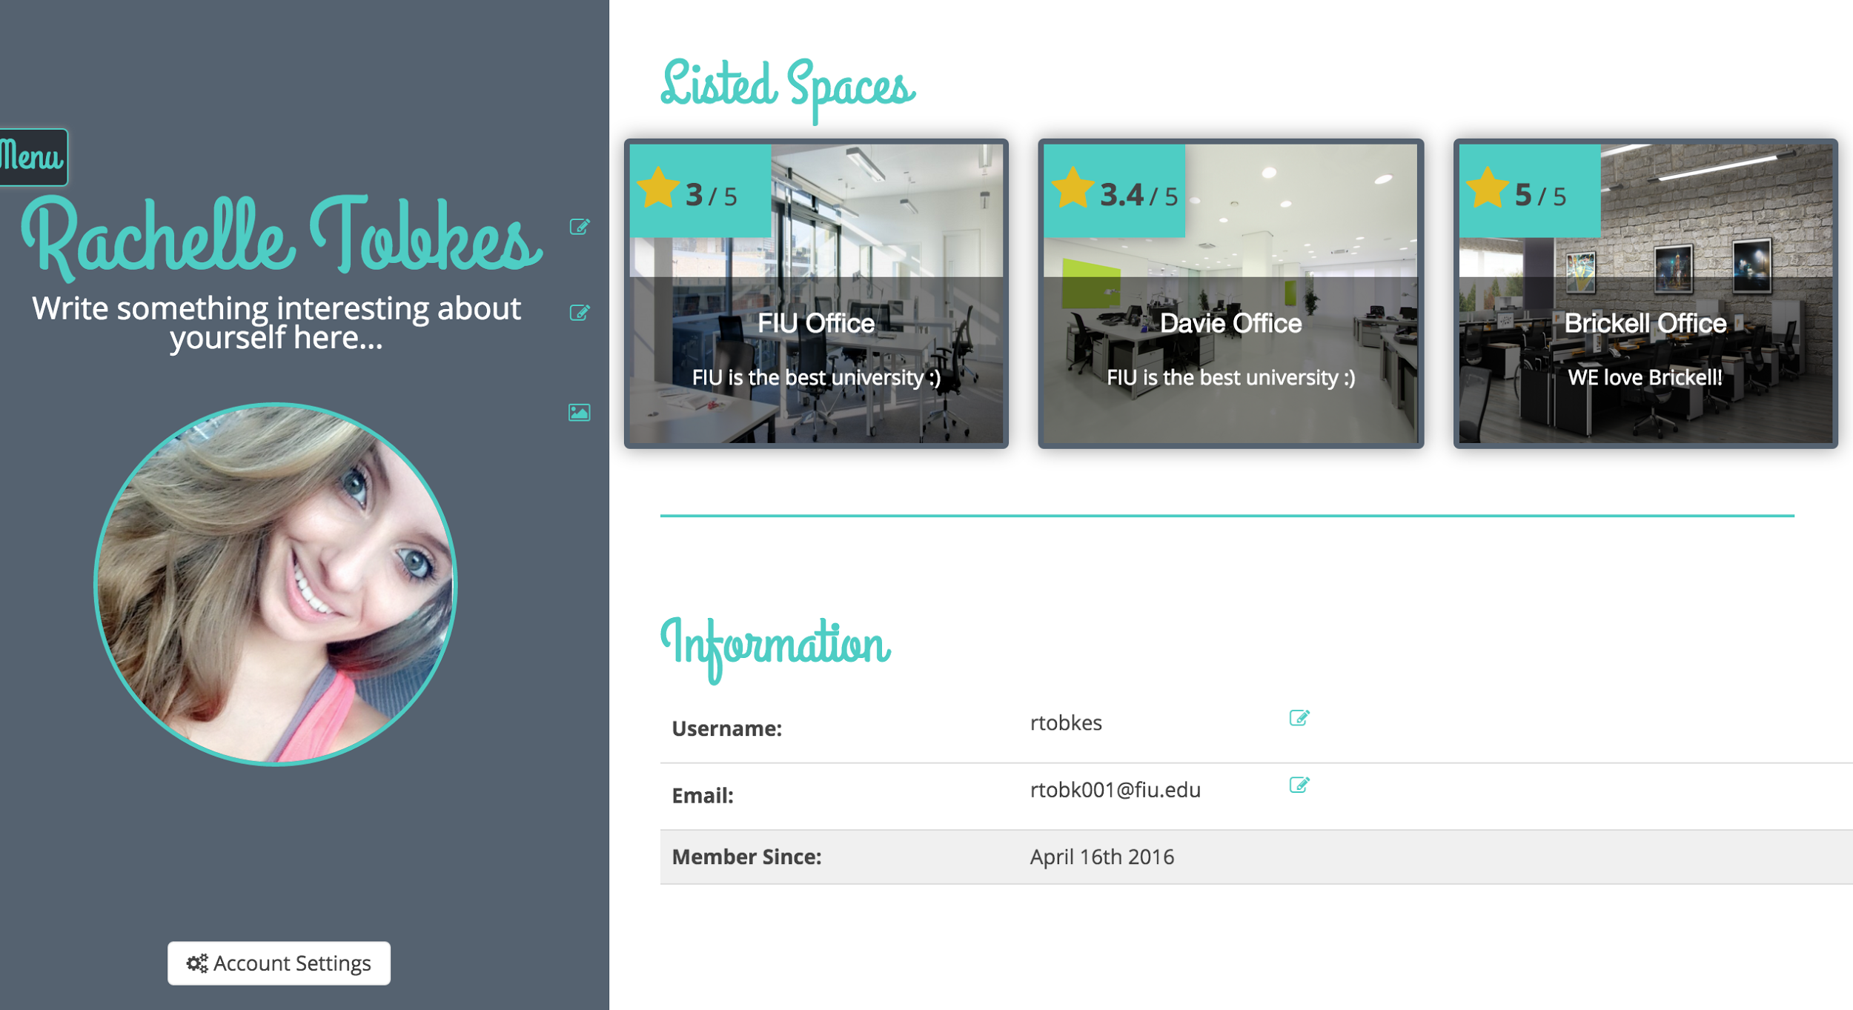

Additionally, account settings has various options to change your password, delete your account, or save your credit card details.

.

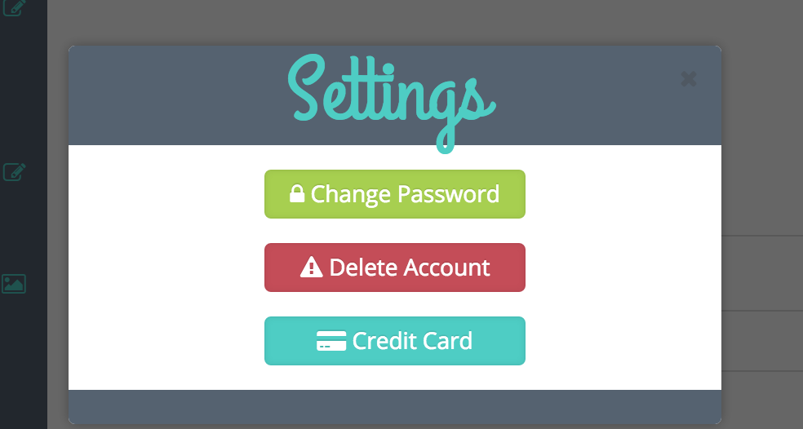

# 

# 

# 

# 

# Rent Office Space

____________________________________________________________________________

Once you click the “Rent Now” button on the page of the office space that you wish to rent, the following form will be displayed:

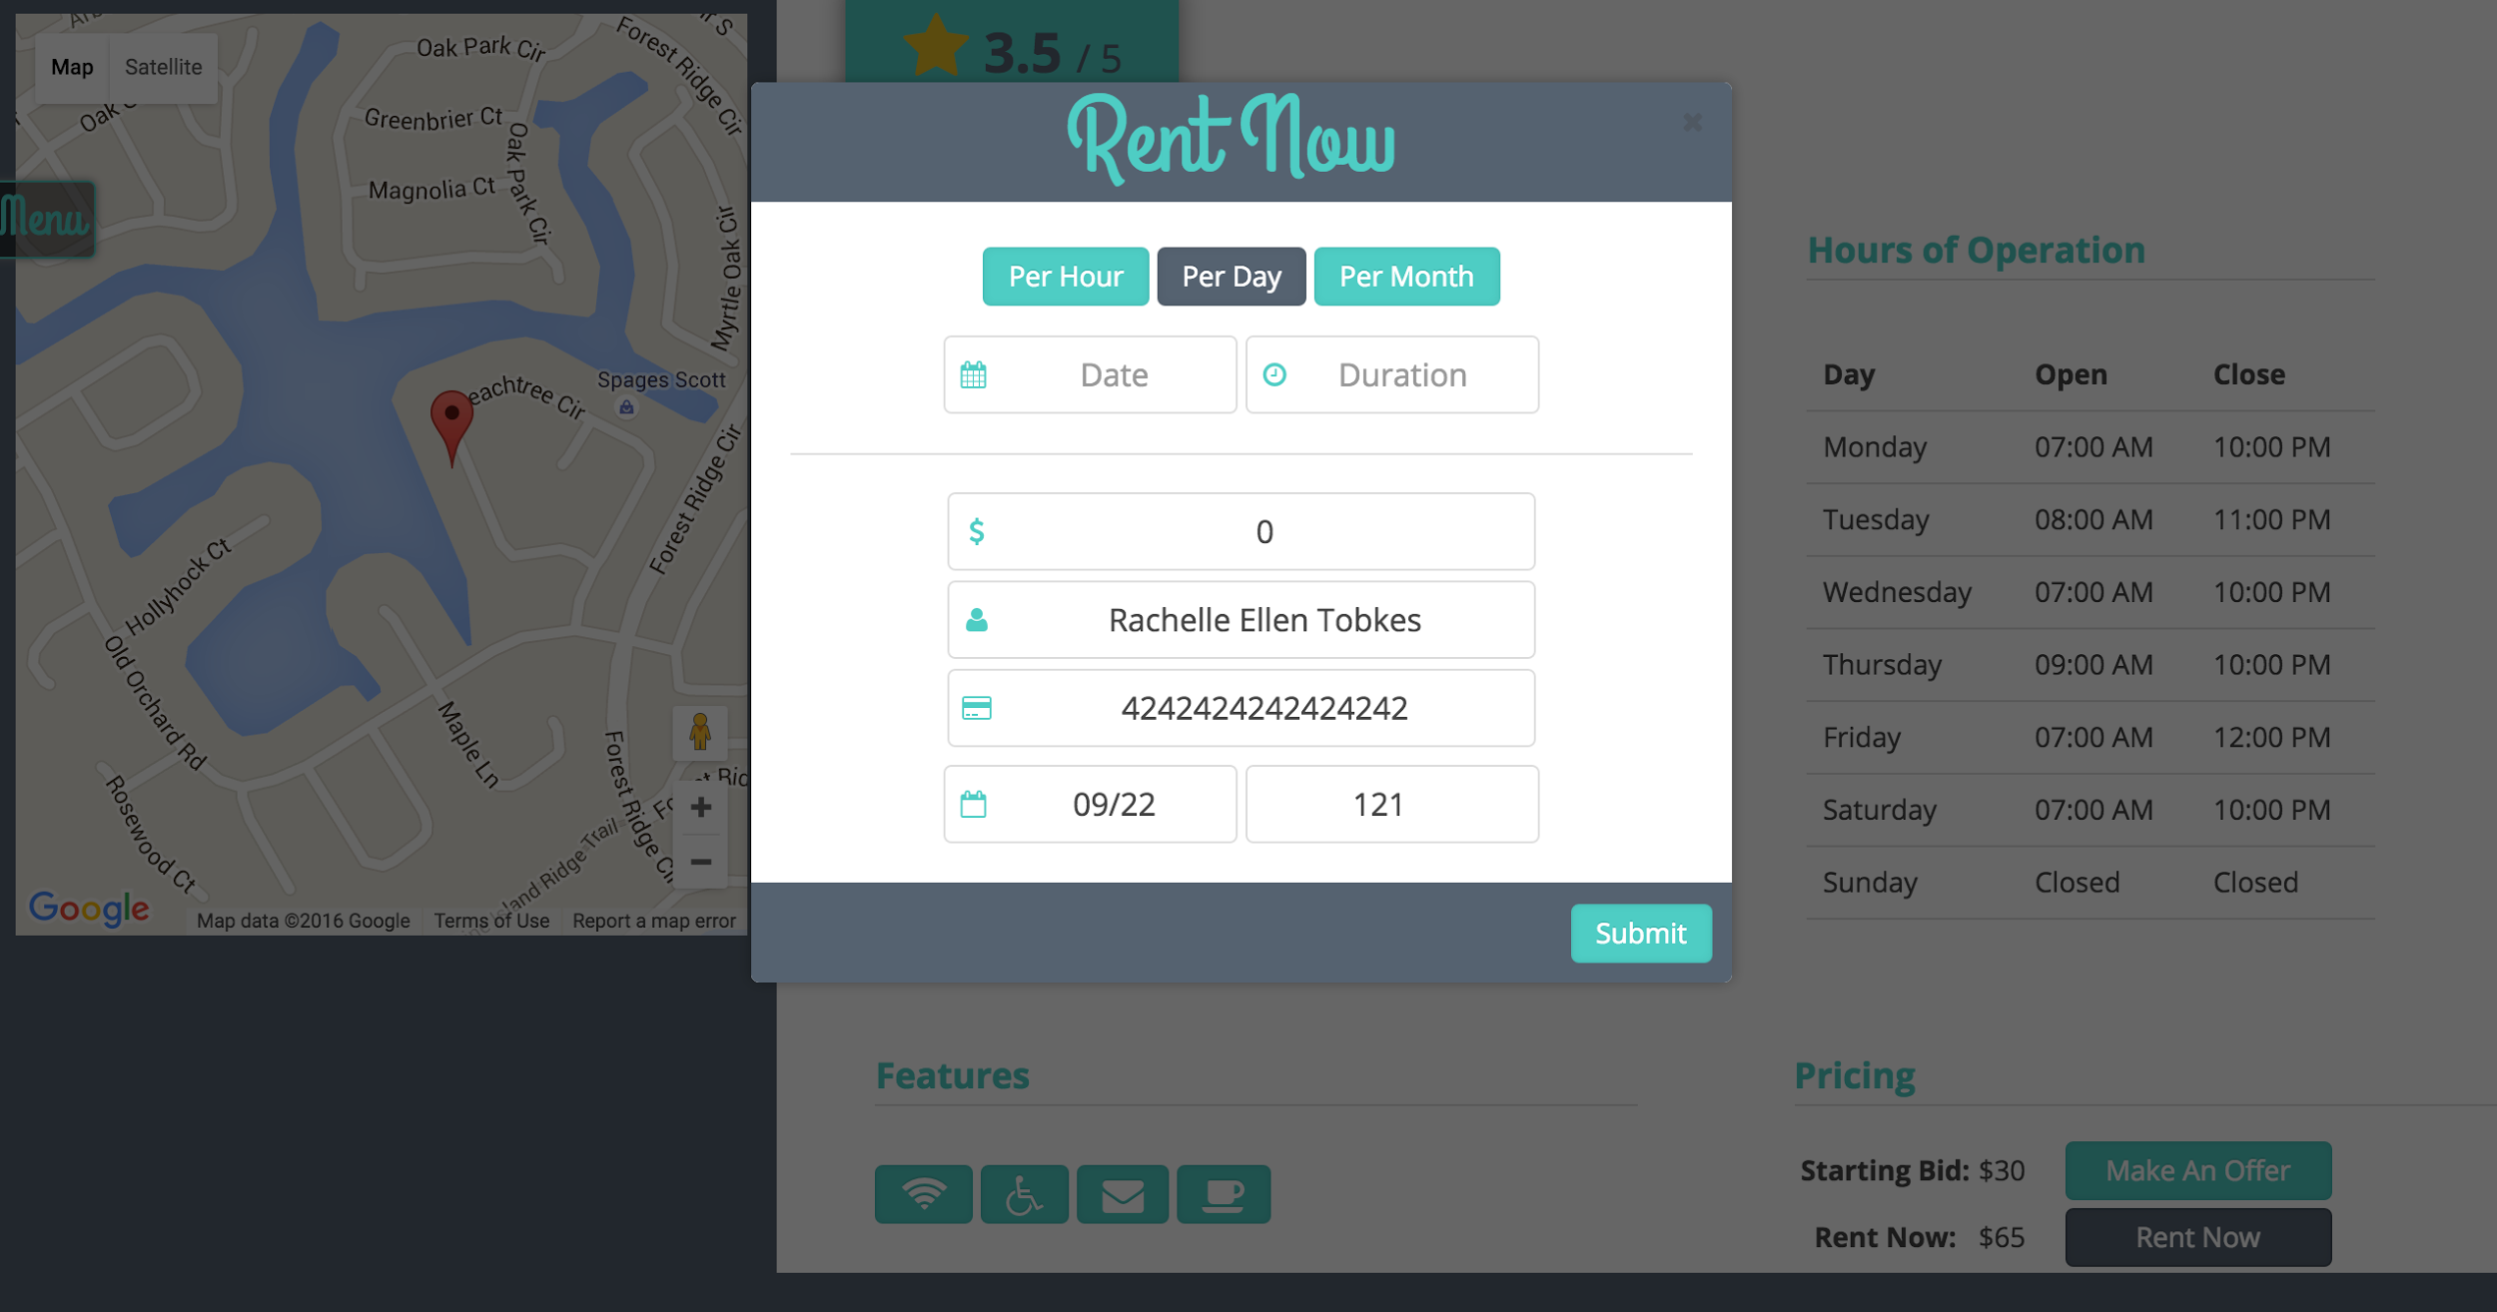

Select your type of rental by choosing Per Hour, Per Day, or Per Month.

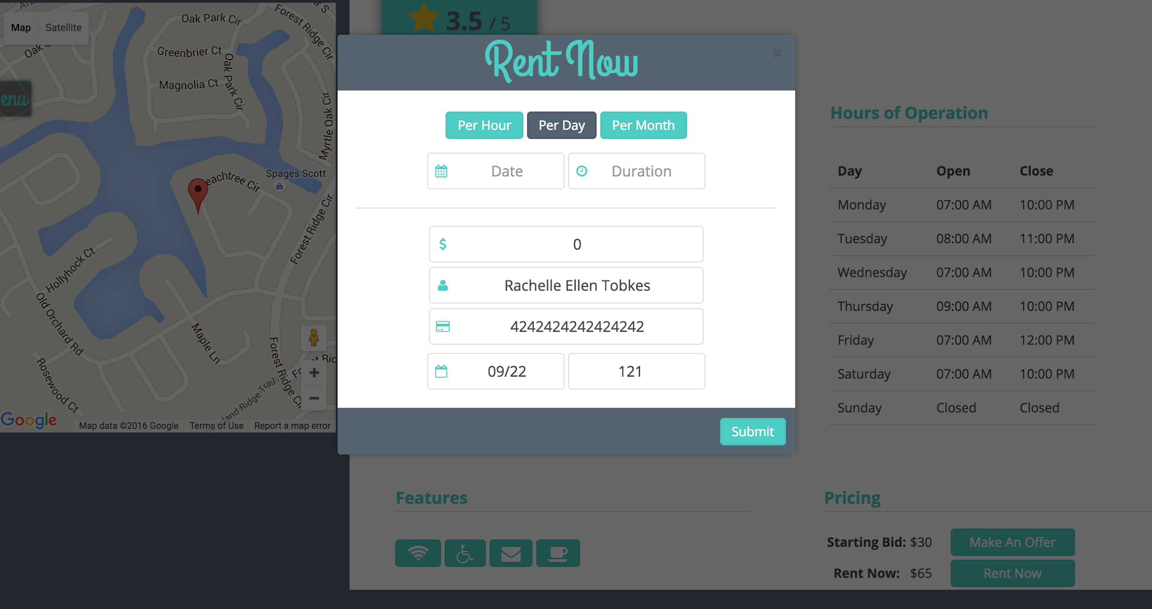

For Per Hour, select a date from the calendar to view its availability. The dates and hours that are disabled are not available for rent.

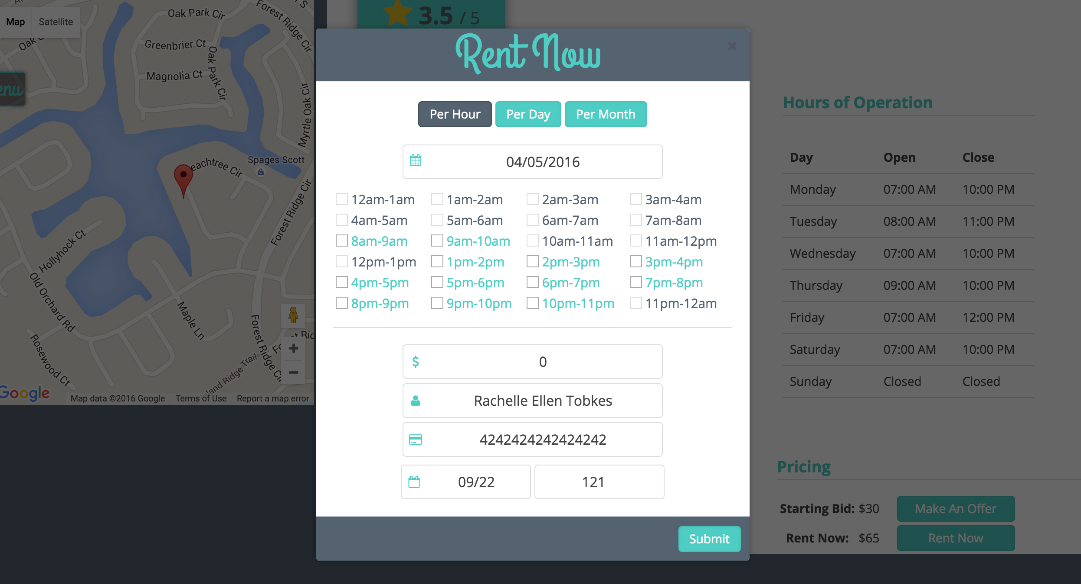

Fill out the form with your information. Select the hours that you wish to rent and watch the price change.

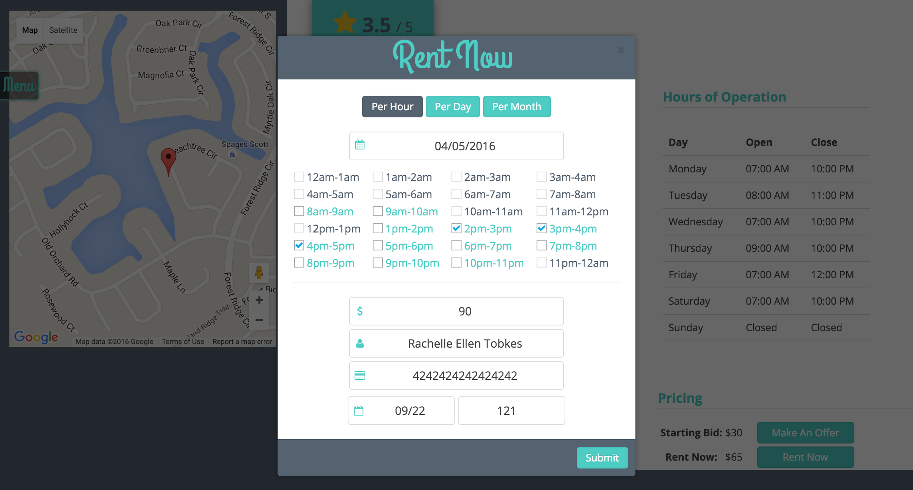

When you are ready, click submit. You will be presented with the following notification:

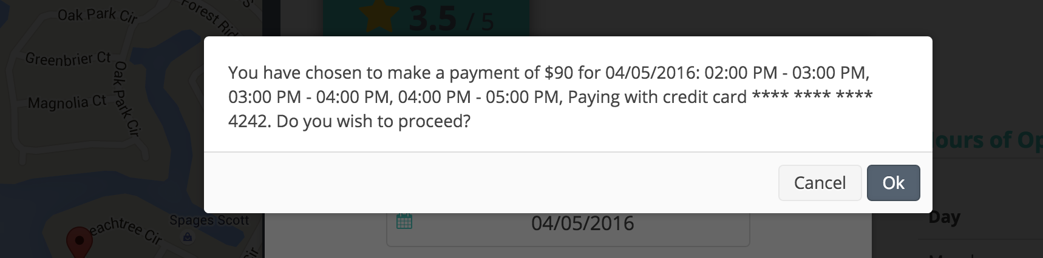

Congratulations! You have now rented an office space. You will see the following notification:

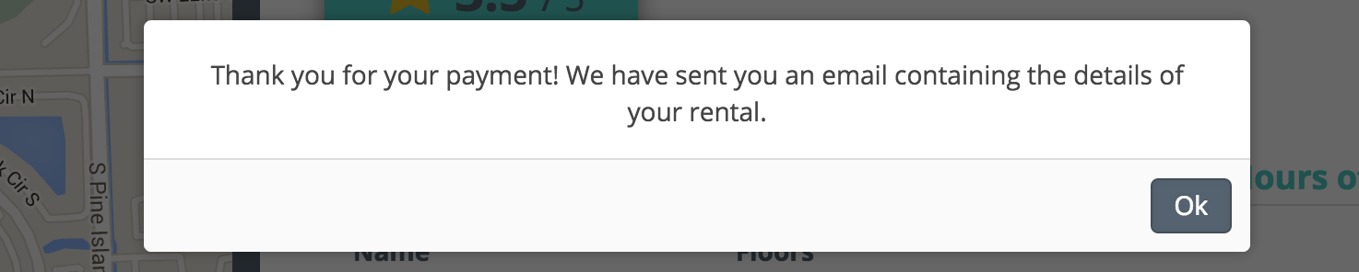

And get an e-mail similar to the one below:

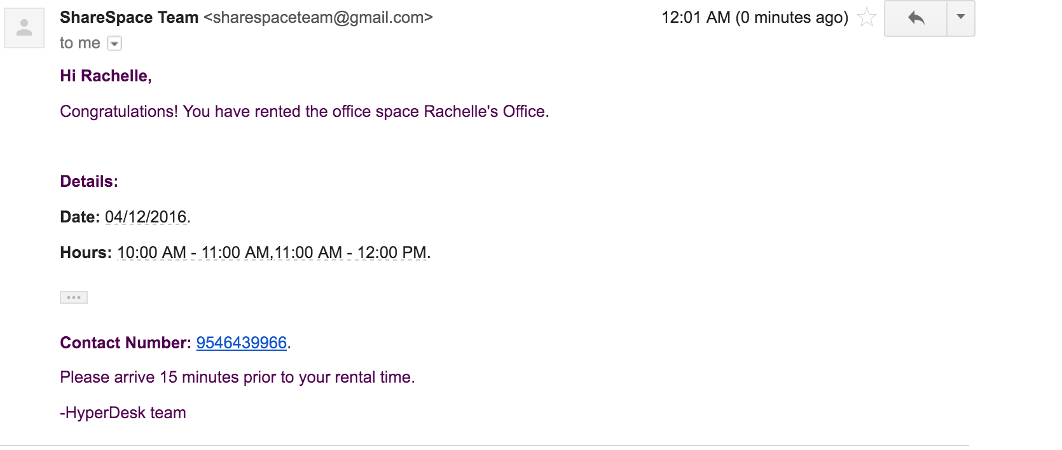

# Logout

____________________________________________________________________________

The logout button can be seen on the top left corner of the web page, once logged in.

